Technical Manual

RadPortal

Developed By -
Miracle Advance Technology

Last Update Date -
02/15/2023

This Document Is for the RadPortal Application
Version – 1.5.0

Written By -
S. M. Al Shahaneaz Shaikat

Revision Sheet

Release No. | Date | Revision Description | Author Name
V 1.1.0 | 16/02/23 | Study submits with Govt Info, Govt Info Submit | S. M. Al Shahaneaz Shaikat
V 1.2.0 | 02/05/23 | New Dashboard | S. M. Al Shahaneaz Shaikat
V 1.5.0 | 09/11/23 | Update Govt. info submitted, Review in Reporting, radiologist Profile View, Exam Info, Integration Monitoring Center, reports | S. M. Al Shahaneaz Shaikat

USER'S MANUAL OF RADPORTAL

Table of Contents

1. Getting Started as HealthCare Service Provider 5
1.1 Signing Up 5
1.2 Logging In 12
1.3 System Menus 13
1.4 How to Change Password, Change Profile Picture, and Add Your Digital Signature 14
1.4.1 Changing Password 14
1.4.2 Changing Profile Photo 16
1.4.3 Adding Digital Signature 17
1.5 Software Version and Updates 18
1.6 Sign Out from The System 19
2. Exploring Worklist Menu 20
2.1 How to Search Studies 21
2.2 How to Sort Studies 22
2.3 How to Upload DICOM files and folders 23
2.4 How to Organize Information of Studies 28
2.5 How to Delete/Cancel, Reconcile/Edit studies and attach additional files to studies 31
2.5.1 How to Delete/Cancel 31
2.5.2 Reconcile/Edit Study 32
2.5.3 How to Add/Remove Documents 33
2.6 How to Submit studies 35
2.6.1 Edit Study 36
Patient Type[1] 37
Service Type[2] 38
Turnaround Time[3] 38
Accession No[14] 39
Study[16] 39
Govt. Code[17] 39
2.6.2 Documents 39
2.6.3 History 41
2.6.4 Information to add in the Govt Info 43
2.6.4.1 General 43
2.6.4.2. ADP 44
2.6.4.3. AER 44
2.6.4.4. INS 45
2.6.4.5. ODX 45
2.6.4.6 OOP 45
2.6.4.7 ORF 46
2.6.4.8 PAT 46
2.6.4.9 OPD 47
2.7 View Study Reports 49
2.8 How to Delete/Cancel Studies 52
2.9 How to Review Finalized Reports Submitted by Radiologist 54
3. How to Track Studies 57
4. Integration Monitoring Center 59
5. Reports 60

1. Getting Started as HealthCare Service Provider
Signup and Login Workflow

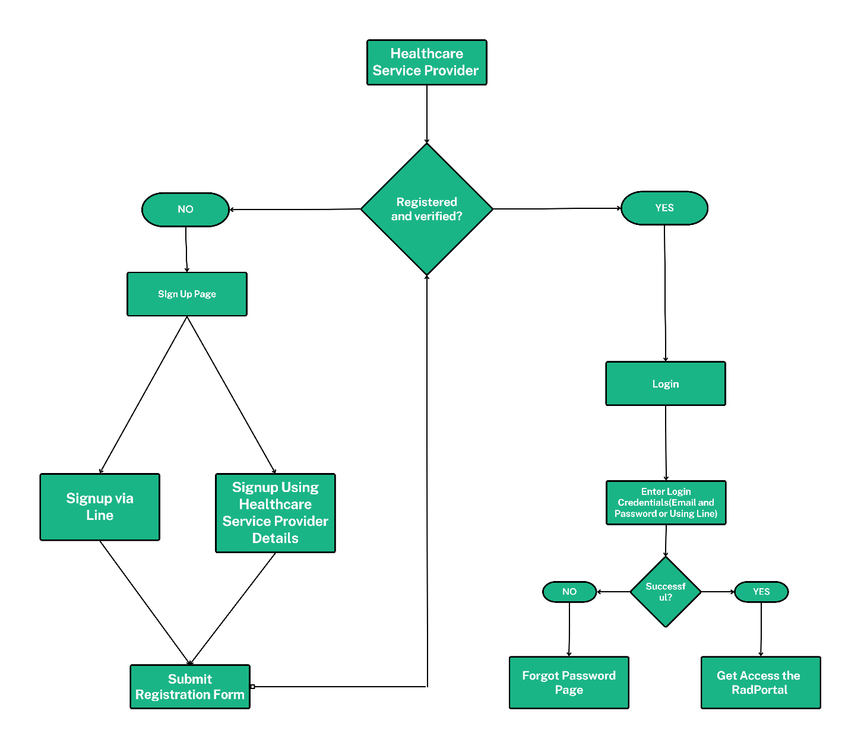

1.1 Signing Up
Before using the RadPortal system, you have to sign up as a HealthCare Service Provider. To sign in, you have to go to this URL - https://radportal.net.
After the website loads, you should see a page like this.
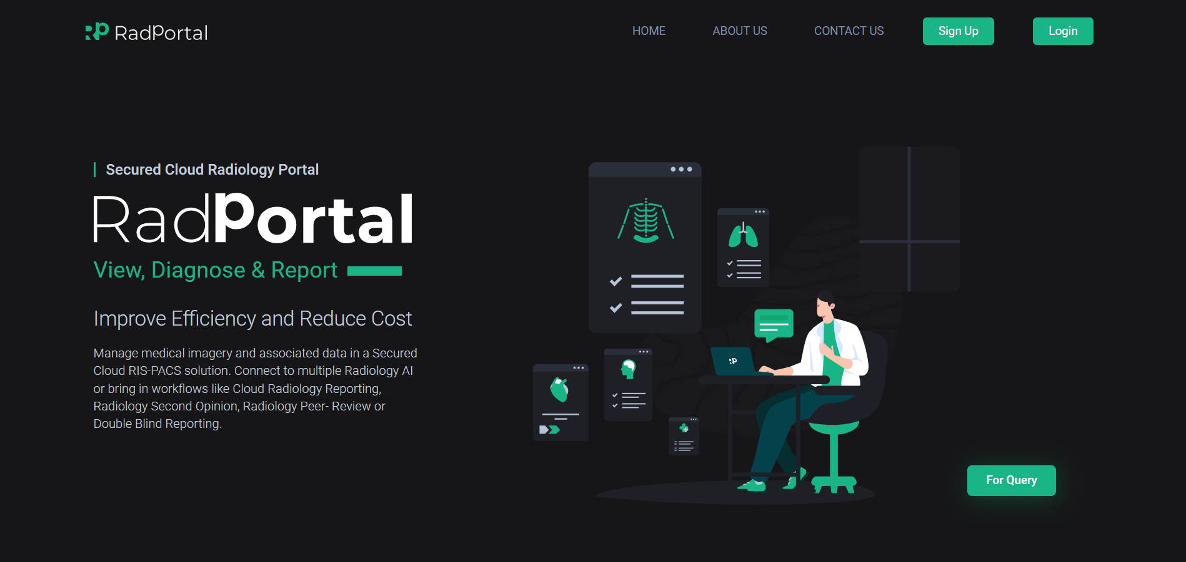

To sign up as a HealthCare Service Provider, click on the Sign-Up button.
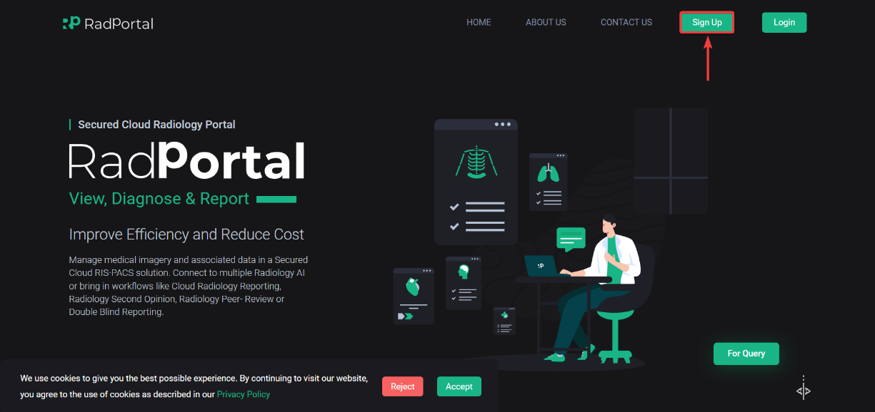

After clicking, you should see a page where you have to click on the Sign up as a Healthcare Service Provider button.
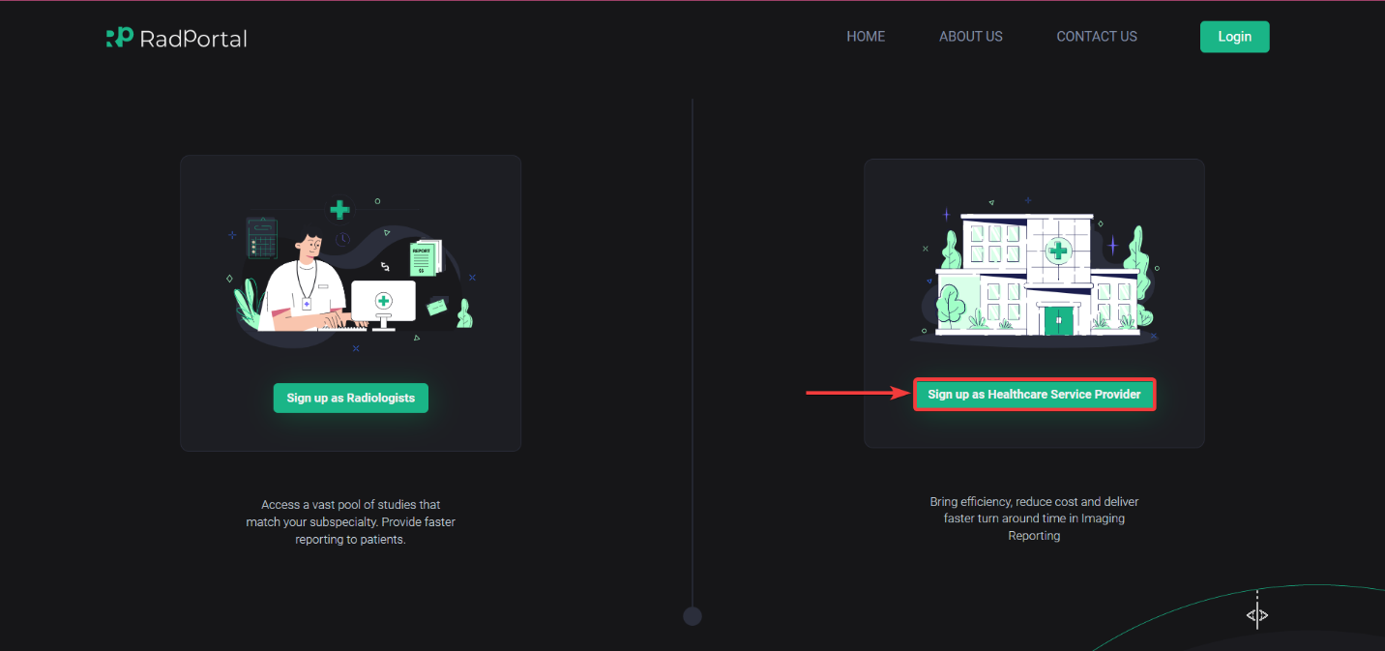

Now you will be forwarded to the HealthCare Service Provider sign-up page, where you have to sign up using your Email [1] and, click on the Send Verification code [2] button.
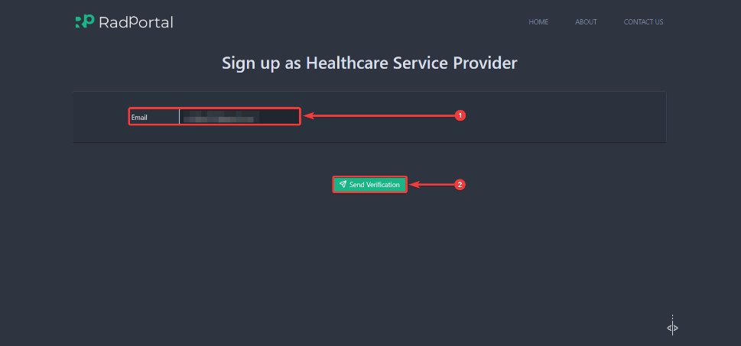
After clicking, you should see the Type Code[1] section pop up under the Email section, where you have to enter the OTP code you received on your email address. Now Click on Confirm[2].
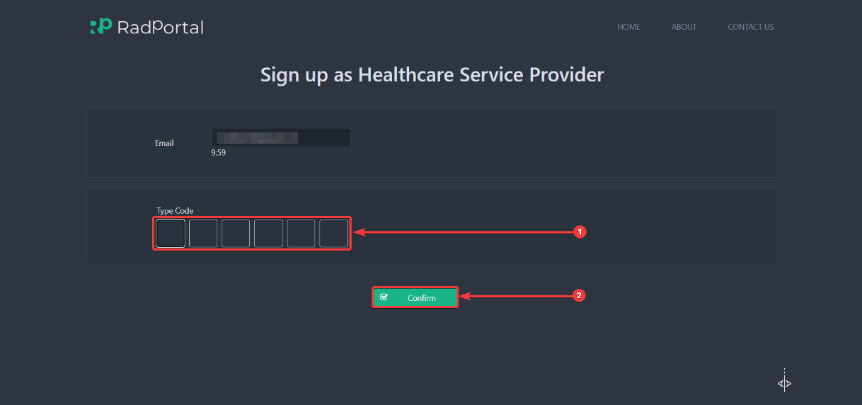

After you enter your OTP code and verify, you should arrive on the Sign Up As HealthCare Service Provider page. On this page, you have two sections.
1. Provide information for the health care Service Provider.
2. Provide information for the Hospital site Admin.
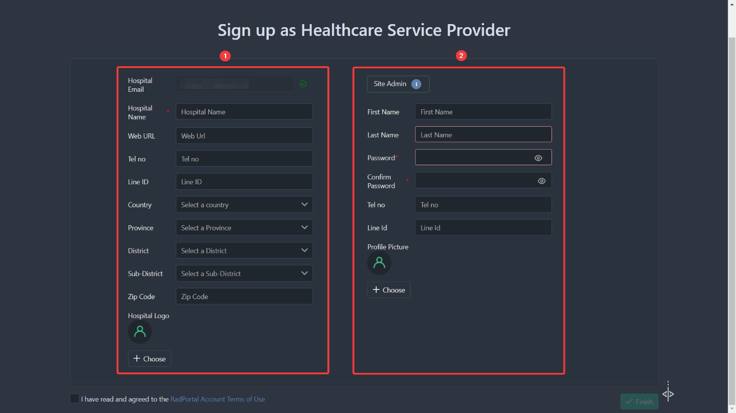

In the first section, you have to enter information such as Hospital Name[1], Web URL[2], Tel no[3], Line ID[4], Country[5], Province[6], District[7], Sub-District[8], Zip Code[9], and Hospital Logo[10].
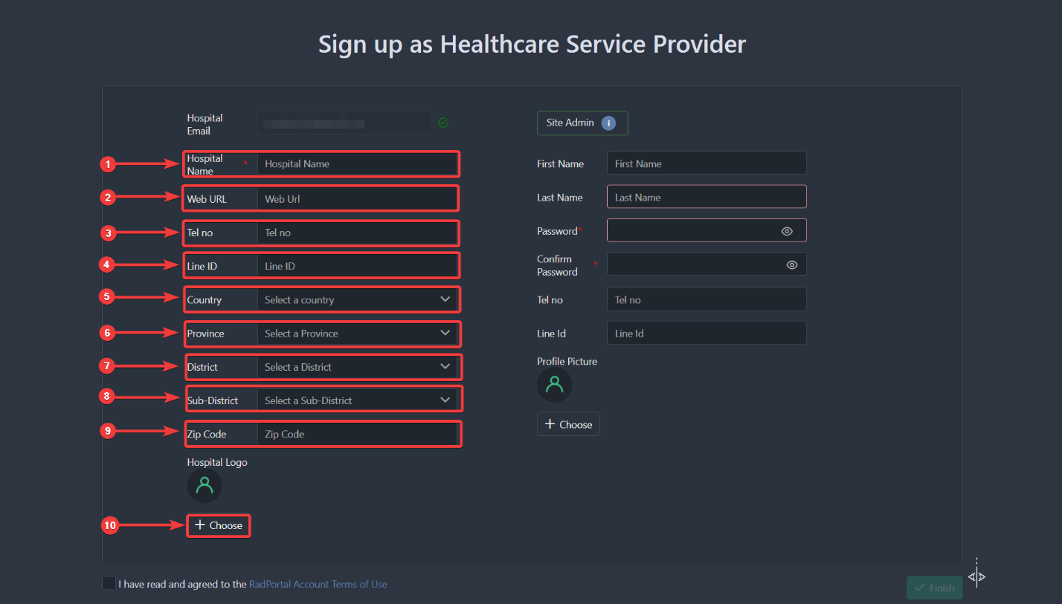

In the second section, you have to enter the hospital's Admin information. The Hospital admin refers to the person who will be in charge of monitoring every process of a hospital. You have to enter the site admin's First Name, Last Name, and Password. The Hospital admin will use this Password to log in to the system. Next, You have to Confirm Password, Hospital Admin's Telephone Number, and Line Id and upload the Site admin's Profile Picture by clicking on Choose button.
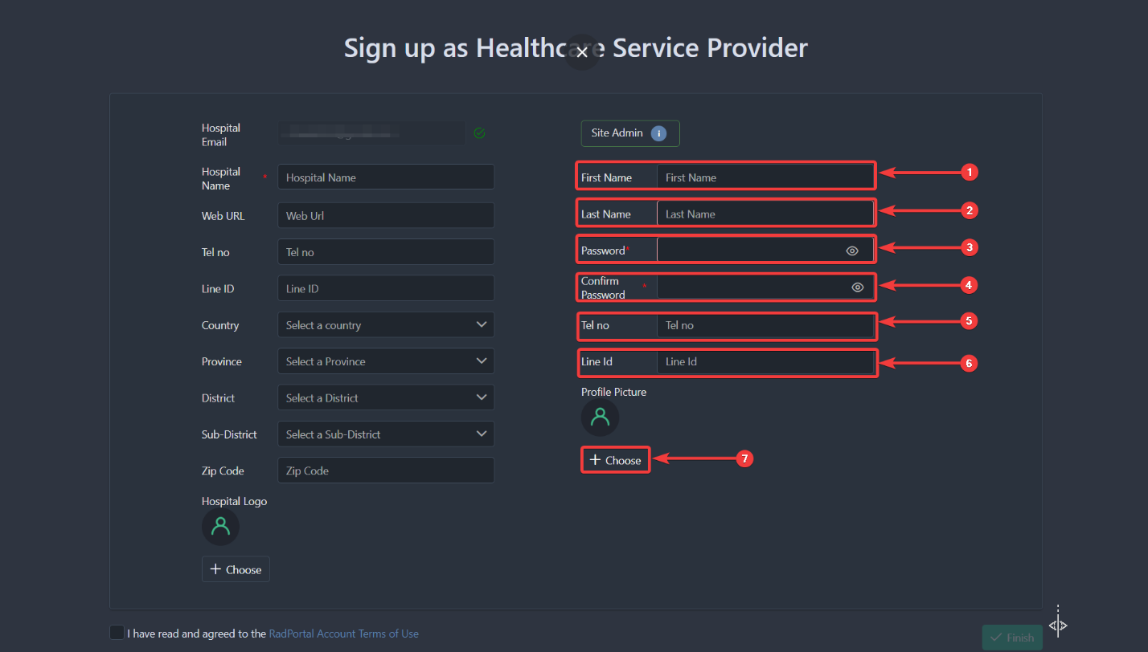

Now you have to click on the checkbox button declaring that you have accepted that you have read and agreed to the RadPortal Account Teams of use.
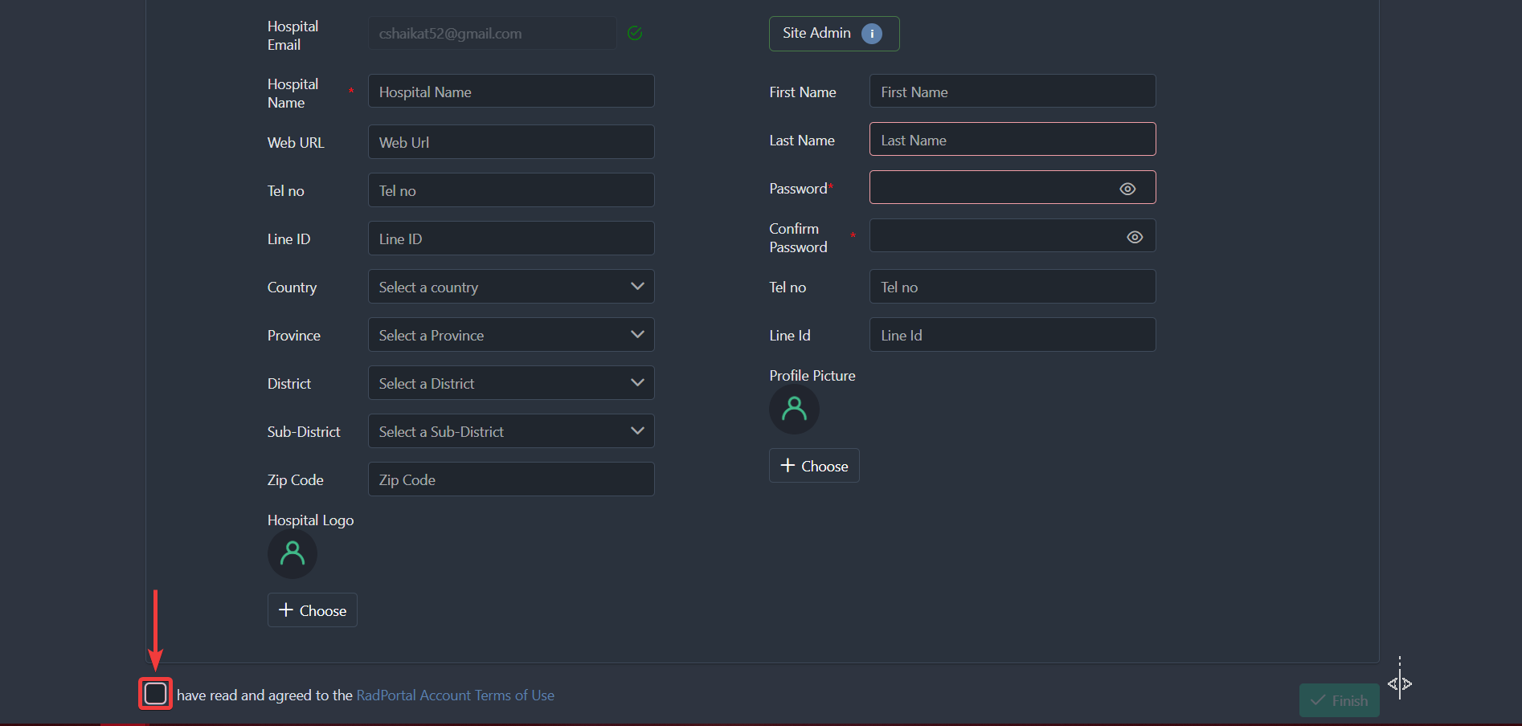

After clicking on the checkbox, you can see that the Finish button is now activated.
Now, click on the Finish Button to complete the signup process.
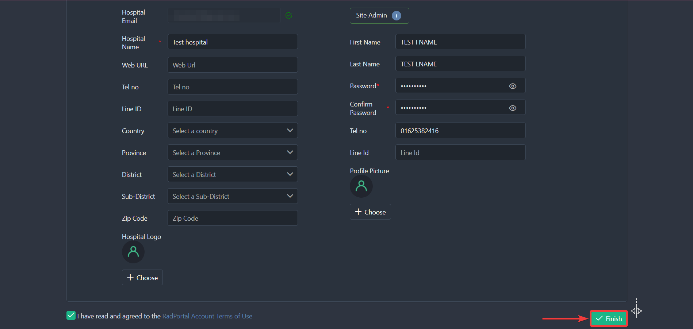

After clicking, you should see a Thank you page.

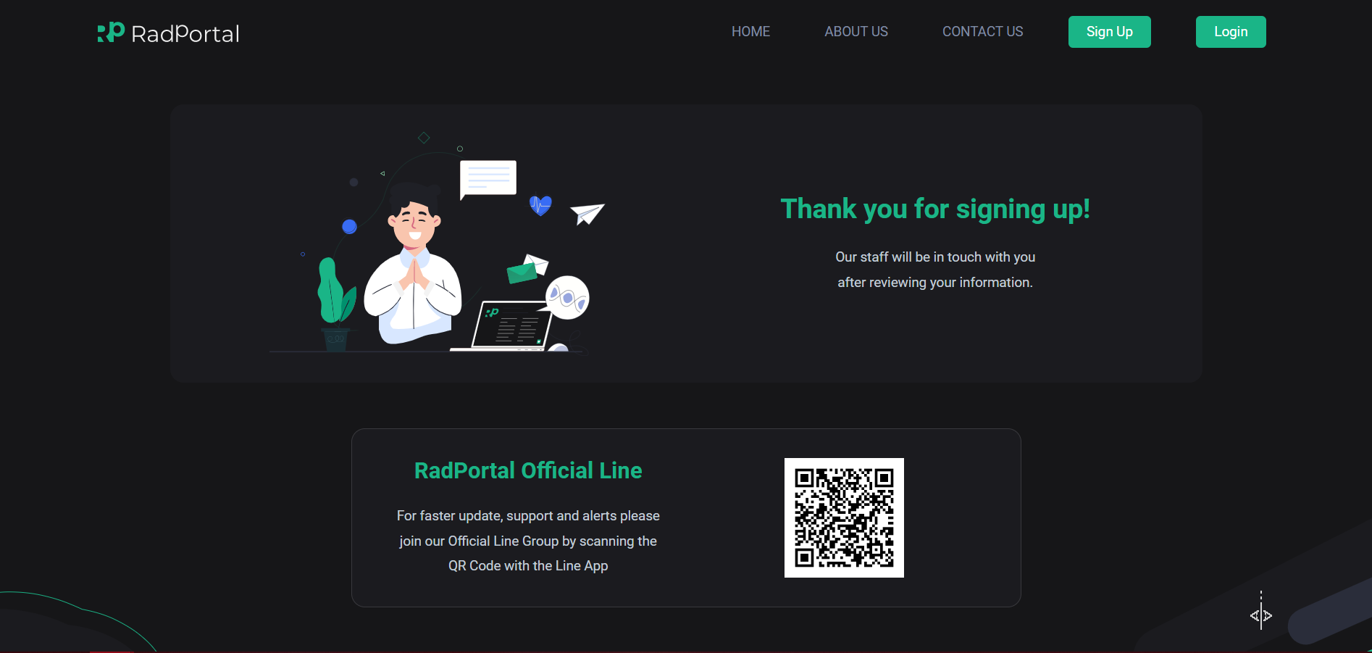
Now, The RadPortal team will manually review your Sign up request. After you are validated and approved, you can access the RadPortal application. You must wait a certain period to get verified by our System Admin. After your details are verified, you should receive a welcome email from our end.

1.2 Logging In
To log in, you have to go to this URL – https://app.radportal.net/#/login. After the login page loads, you should see a page like this
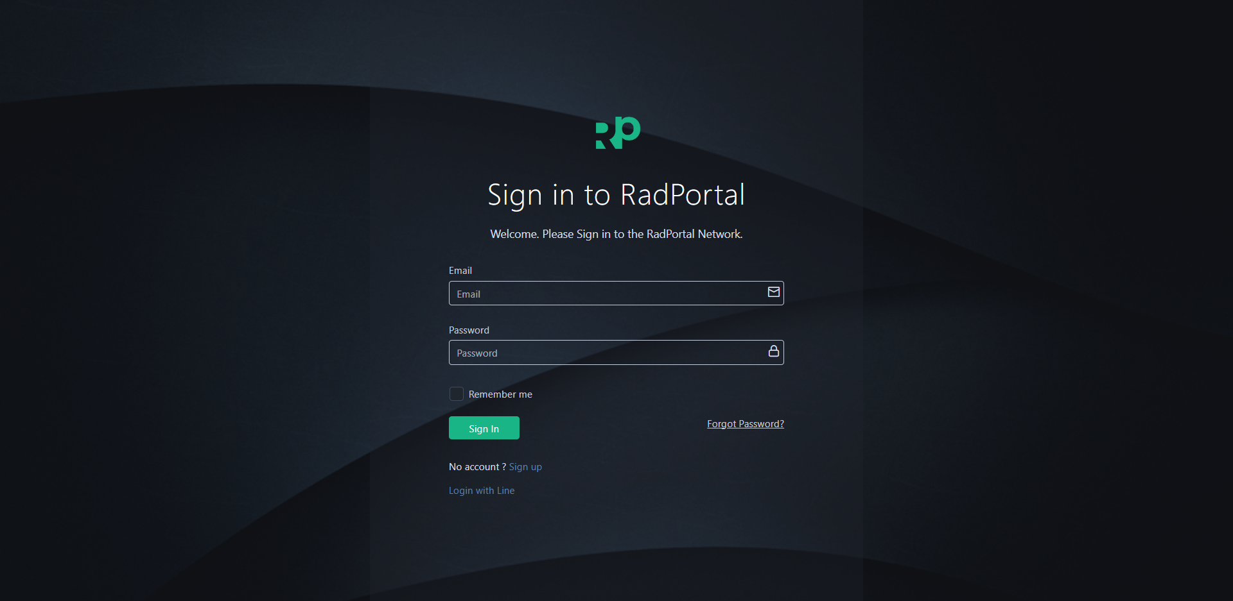

After you access the login page, you can use your Email [1] and Password [2] to log in to the RadPortal. You have to use the login credentials you used to create your account. Finally, click on the Sign In [3] button.
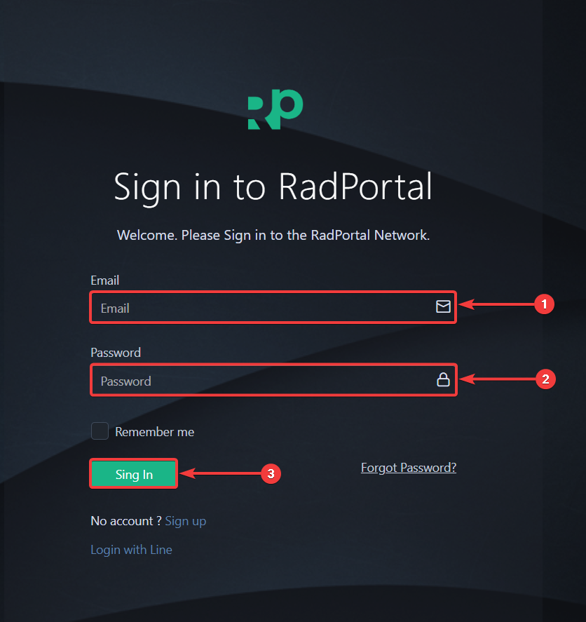

After successfully logging in, you should see the Study Worklist page of RadPortal.
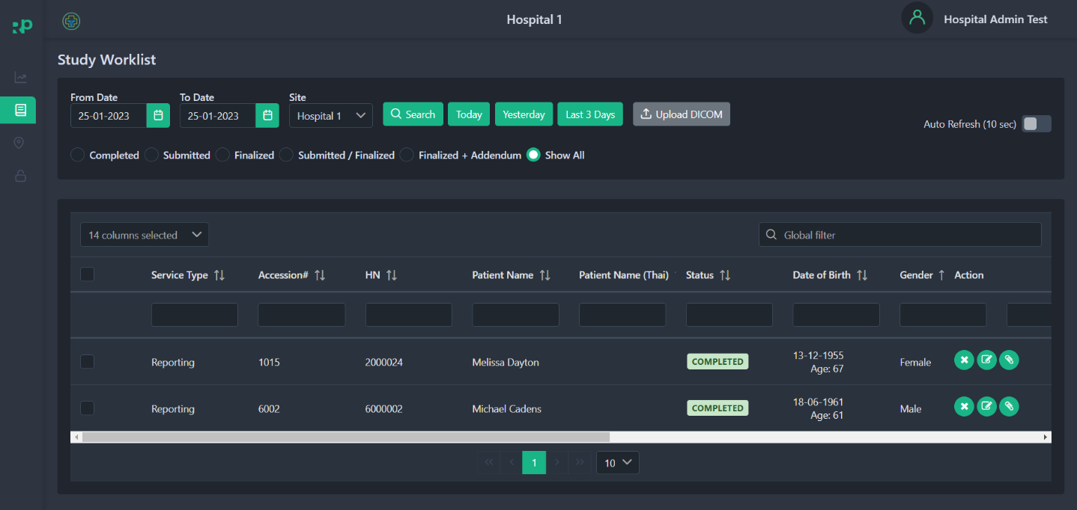

1.3 System Menus

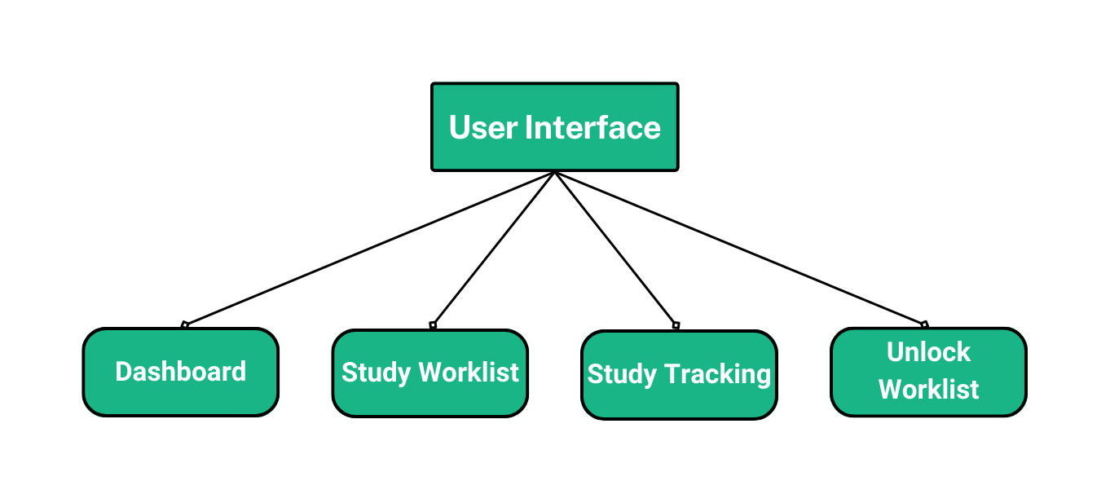

The RadPortal system has these menus currently available for HealthCare Service Providers
- Dashboard
- Worklist
- Study Tracking
- Unlock Worklist

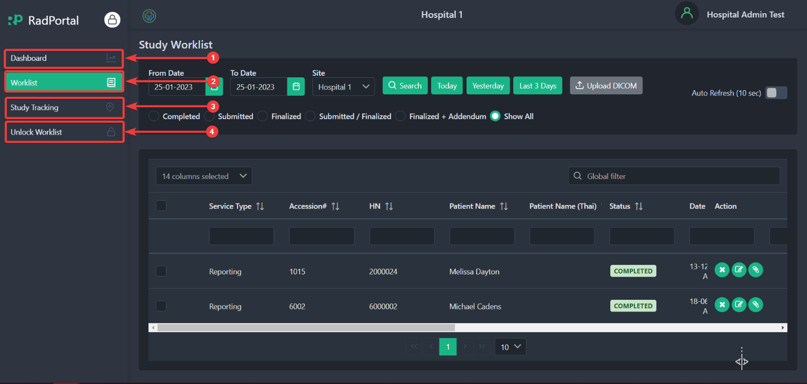

1.4 How to Change Password, Change Profile Picture, and Add Your Digital Signature

1.4.1 Changing Password
You can easily change your RadPortal login password from your profile. To access your profile, click on your Username [1] in the top right corner and click on Profile [2].
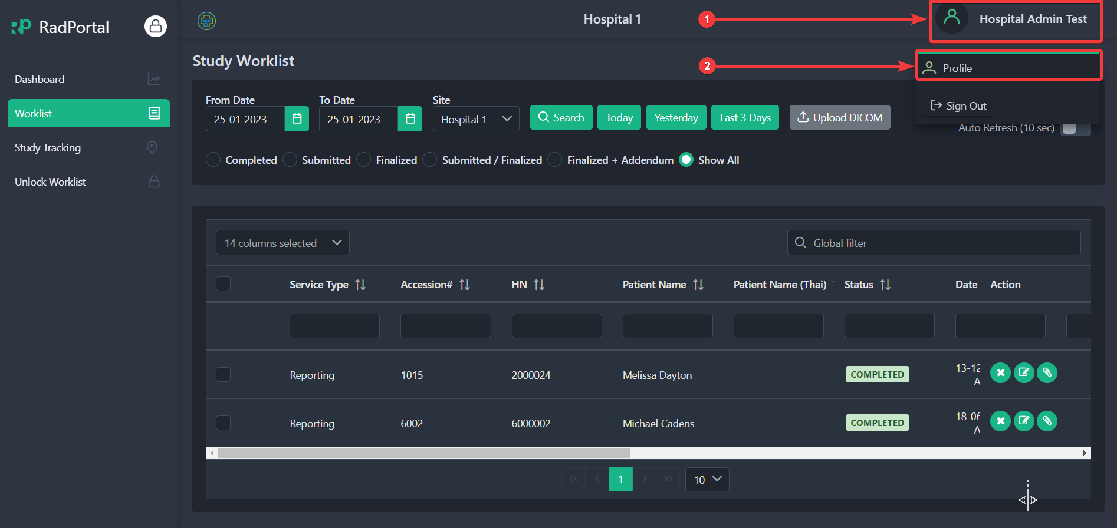

After clicking on The Profile, the system will redirect you to your profile page. On this page, you can change your Password. To change your user Password, click on the Change User Password button.
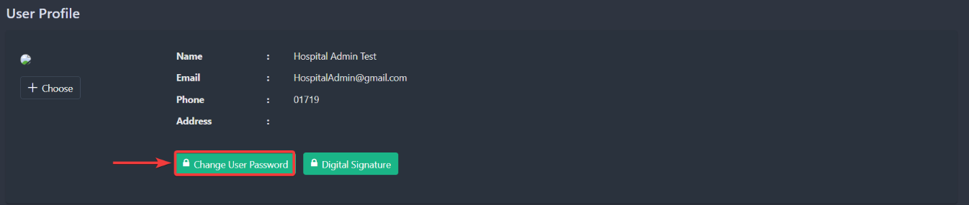

After clicking, you should see a new page where you have to confirm your Old Password [1], enter your New Password [2], and confirm your new Password [3]. Click on the Update button [4] to finalize your new password setup.
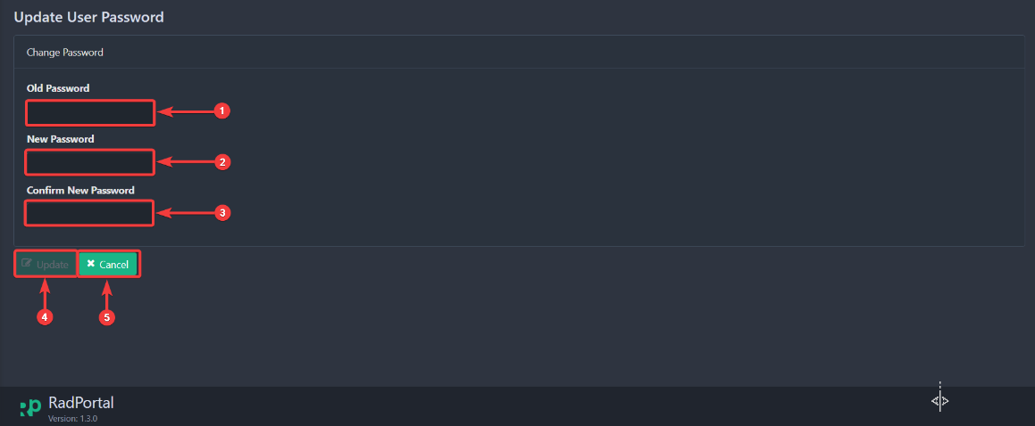

1.4.2 Changing Profile Photo
To change your profile photo, go back to your profile again and click on the Choose button.
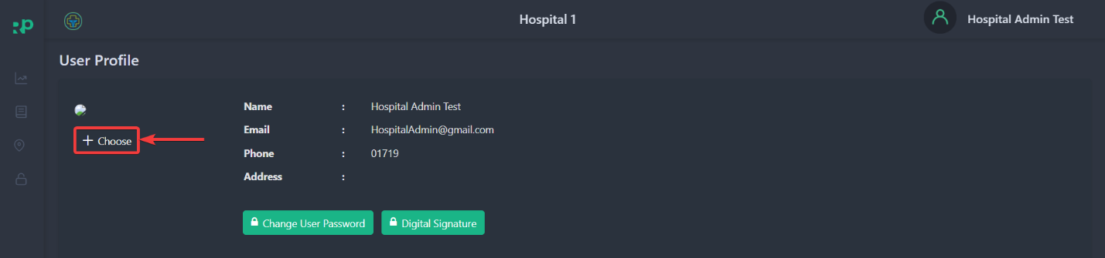

After clicking on the button, you can choose a photo for your profile. You can select your photos directly from your computer. After you upload your profile photo, you will see the preview in the section below.
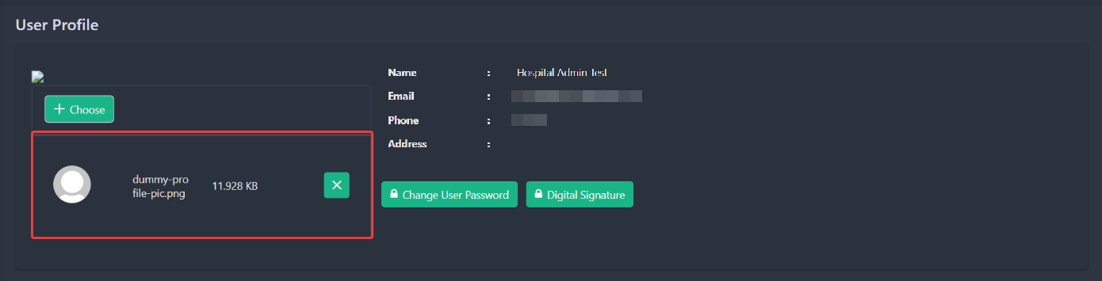

You can remove the photo by clicking on the green cross Icon.
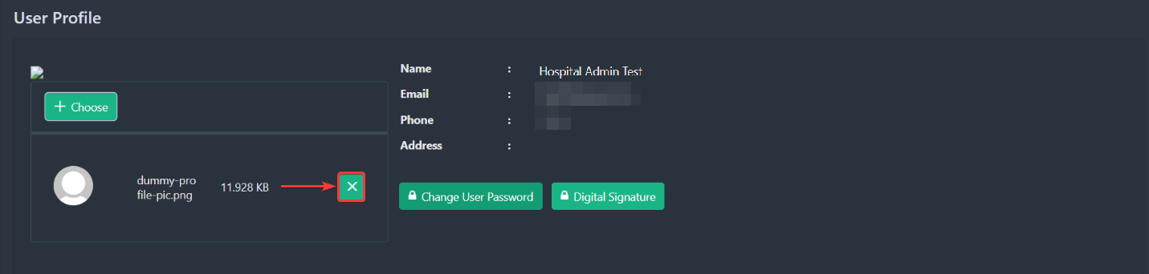

1.4.3 Adding Digital Signature
To add your Digital Signature, go back to your profile and click the Digital Signature button.
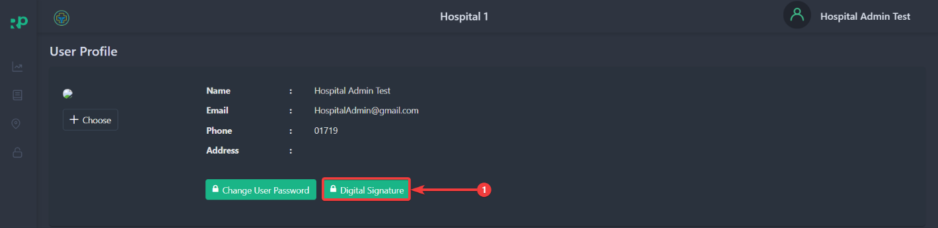

After clicking, you should see a new page where you will be able to upload your digital signature
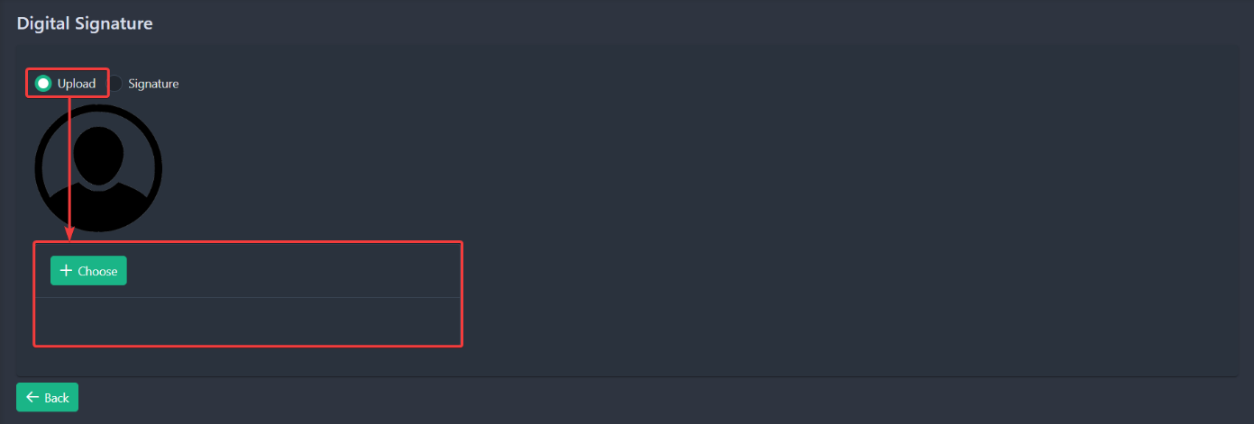

Or you can directly sign in the white blank section.
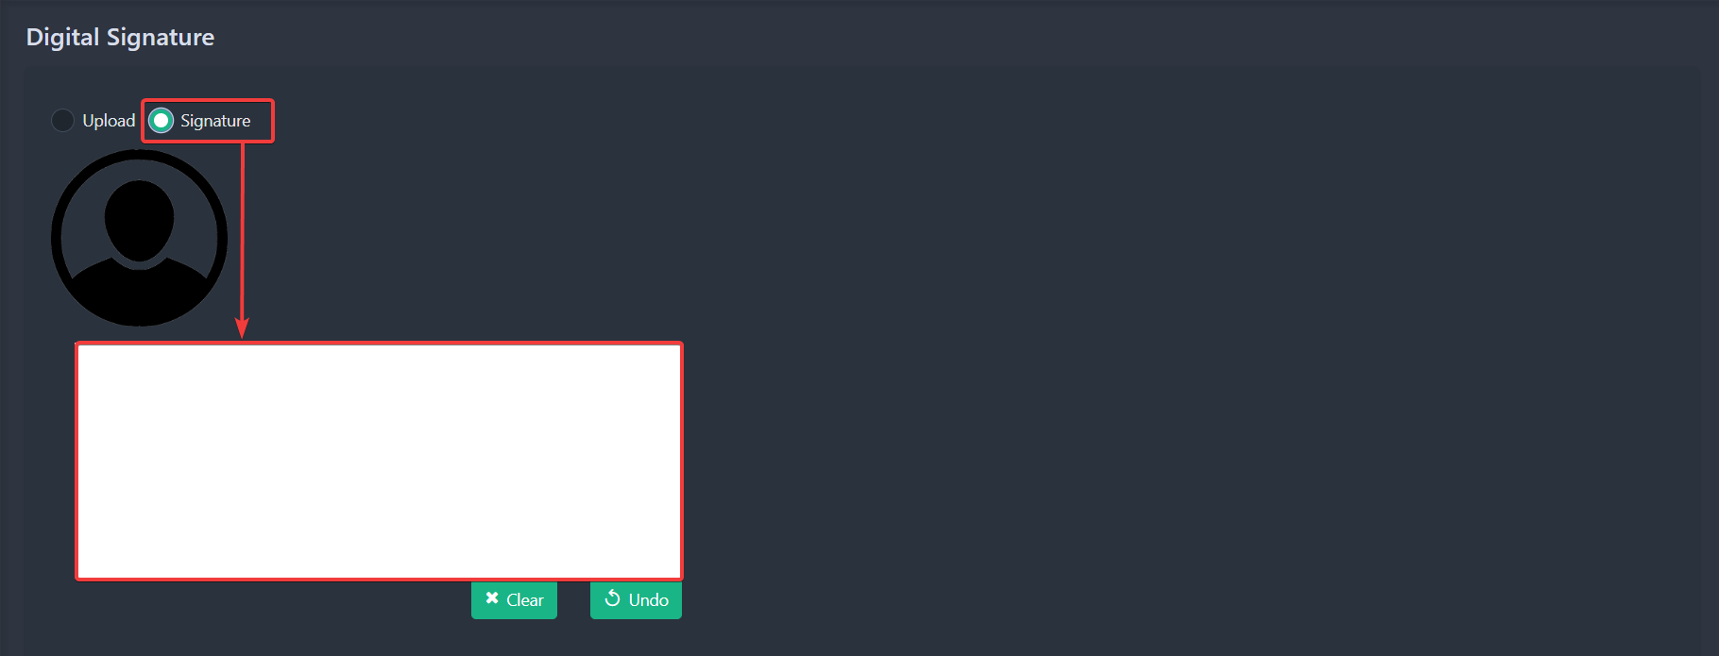

You can Clear your signature or undo the last part you drew by clicking on the Clear or Undo Button.
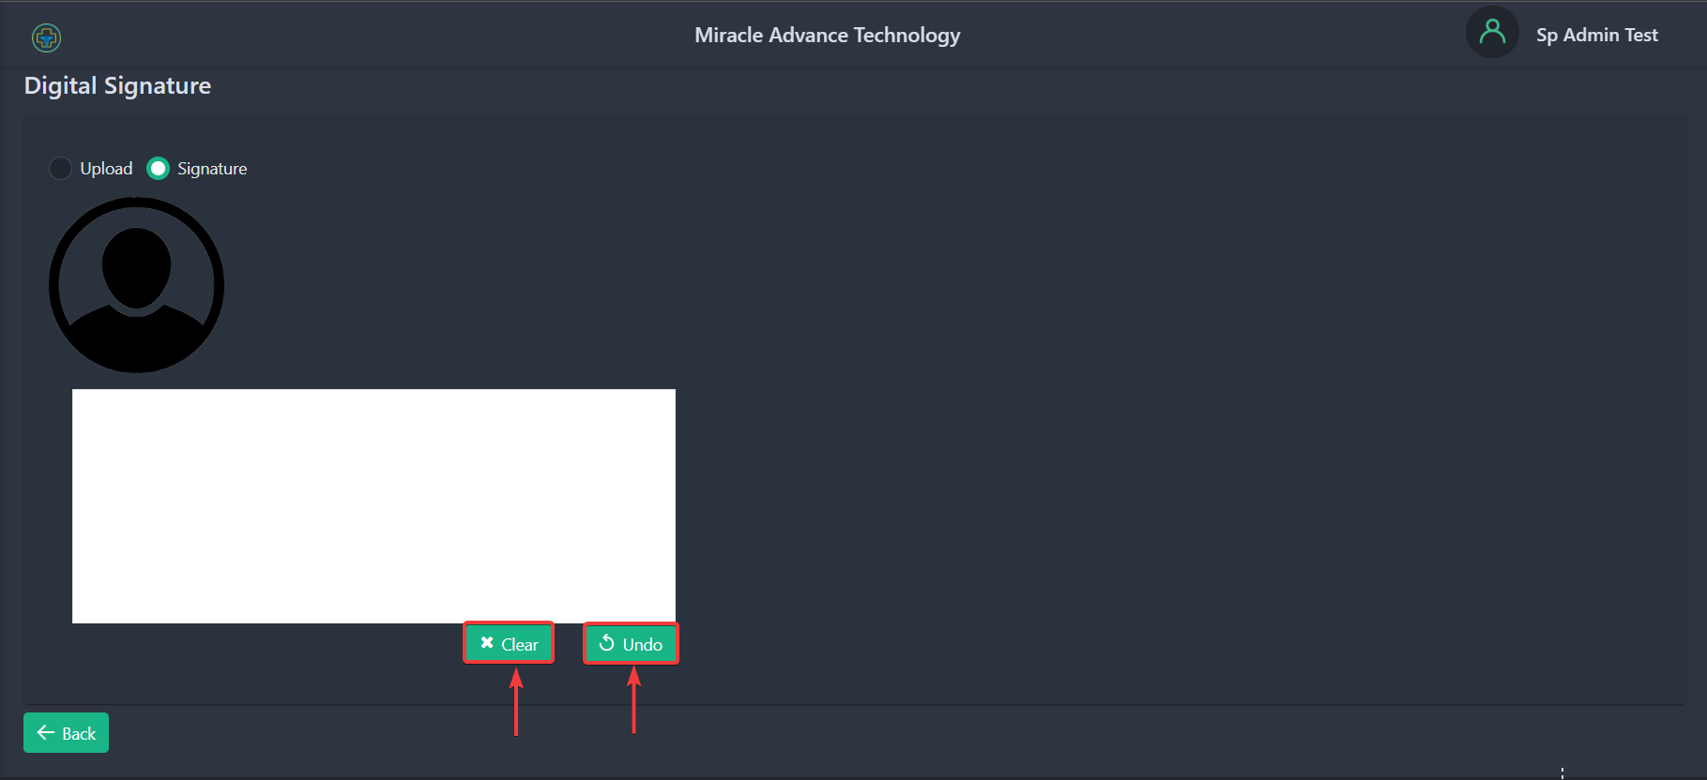

1.5 Software Version and Updates
You can check The RadPortal version in the footer of the application. The most recent Radportal version is 1.4.0.
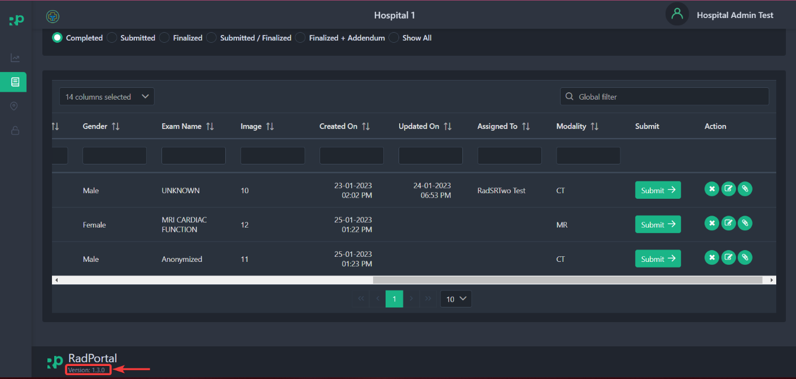

1.6 Sign Out from The System
To Sign Out from the RadPortal system, click on your Username [1] in the top right corner and click on Sign Out [2].

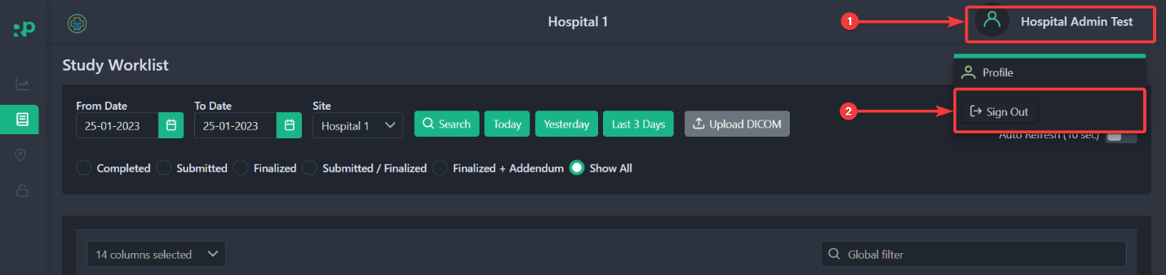

2. Exploring Worklist Menu
Study Workflow
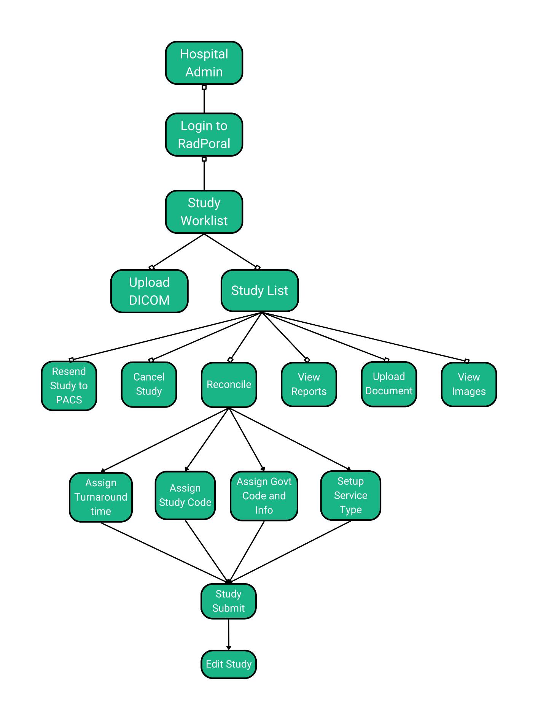

Worklist Module in the RadPortal system allows you to keep track of all New, Submitted, and Finalized studies, or you can search for studies based on certain criteria. Using this Worklist Menu, the HealthCare Service Provider Admin and the Service Provider admin can Upload DICOM files manually, Or studies can be uploaded automatically by a DICOM Router.
The worklist Menu page should look like the screenshot below.
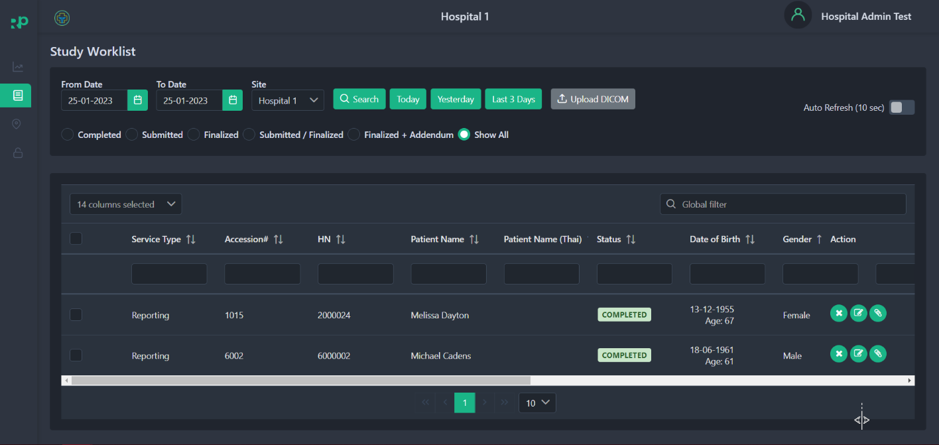

2.1 How to Search Studies
You can custom search based on criteria such as From date [1], To date [2], or you can also search by selecting a specific Site or Hospital [3]. Finally, click on the Search [4] button.
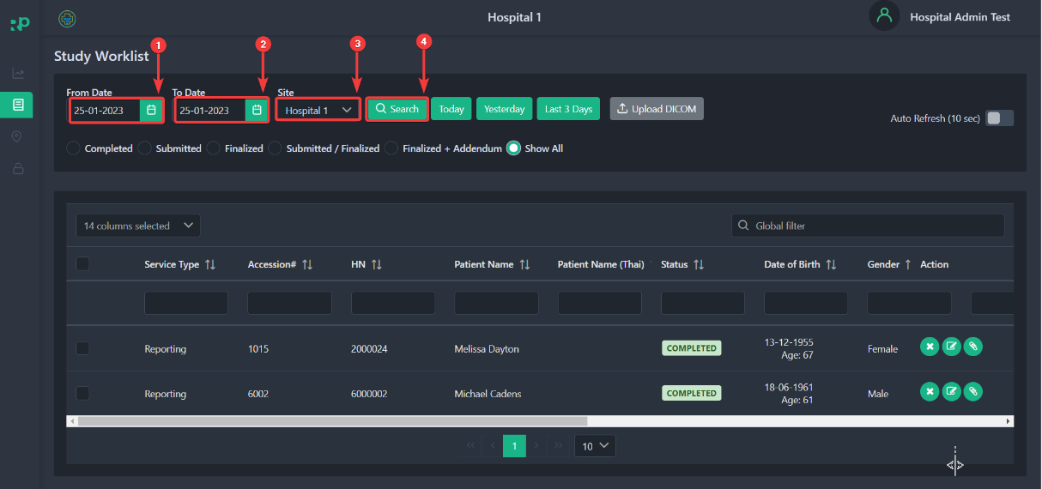
After clicking, you should see all studies/cases that match your custom criteria.
You can even see all studies/cases created Today [1], Yesterday [2], or in the last 3 days [3].
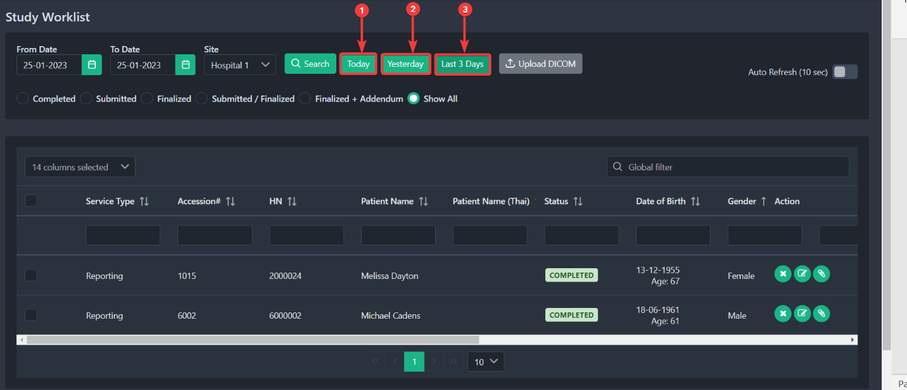

2.2 How to Sort Studies
You can easily sort study-list based on status, such as Completed[1], Submitted [2], Finalized [3], Submitted and Finalized[4], or both Submitted with addendums[5] or To see all studies click on Show All[6]. To sort studies, click on the radio button that you see before each status section.
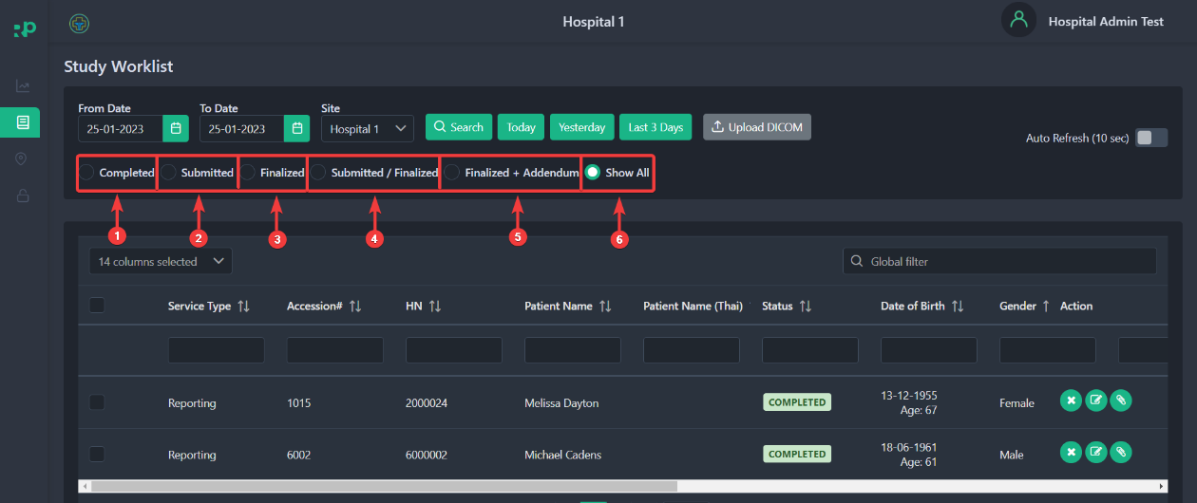

You can enable auto-refresh by clicking on the auto-refresh slide button. After enabling auto-refresh, the page will refresh continuously after every 10 seconds.
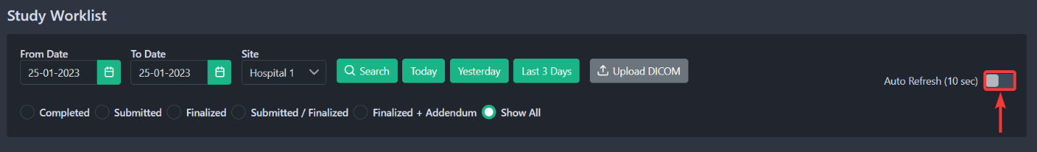
Note: This auto will continue to work until you close the browser window that the application was active on.

2.3 How to Upload DICOM files and folders
You can manually upload a DICOM file in RadPortal. To upload a DICOMs, click on the Upload DICOM button.
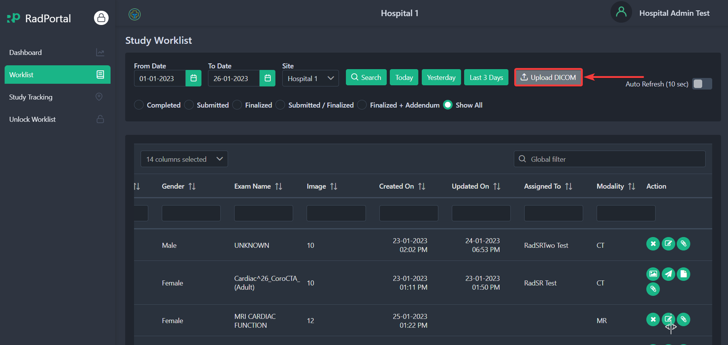

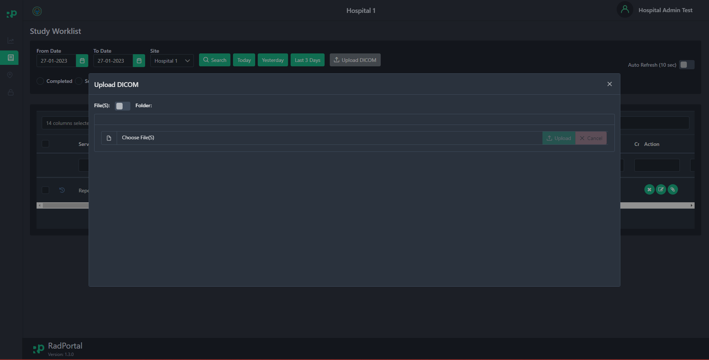
After clicking, you should see a prompt window

There are two ways you can use to upload DICOMs in RadPortal.
You can upload DICOMs by selecting files one by one or bulk upload by uploading a Folder containing multiple DICOM Files.
The application will automatically create studies you upload based on your uploads.
You can switch between uploading files and folders by clicking on the Slide button ().
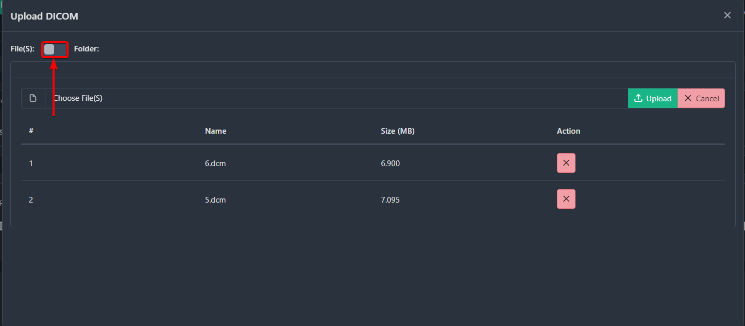

Now, to upload DICOM files, click on the Choose File(s)
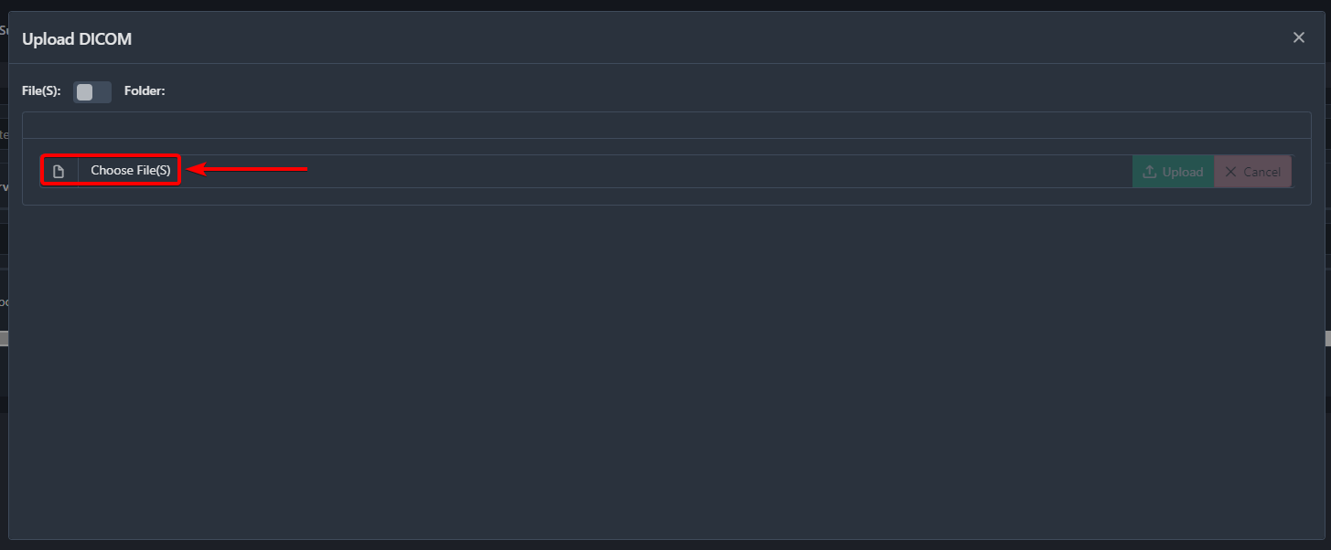

After clicking, select the DICOM Files you want to Upload. In this case, I am selecting these two DICOM files 6.dcm [1] and 5.dcm [2]. You will see the filenames you selected in the File Name field [3].
Finally, click on the Open [4] button.
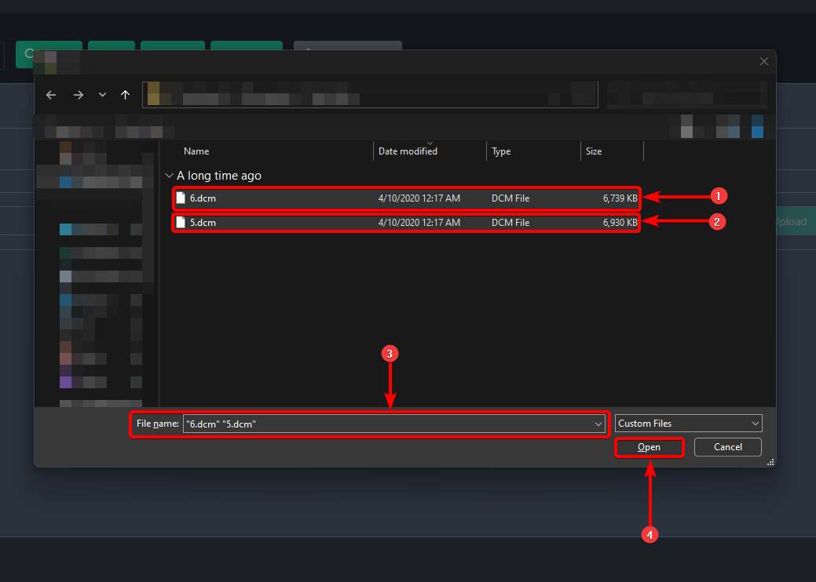

After clicking, you should see the files in the Upload DICOM prompt window. As you can see that the filenames 6.dcm [1] and 5.dcm [2] are now uploaded.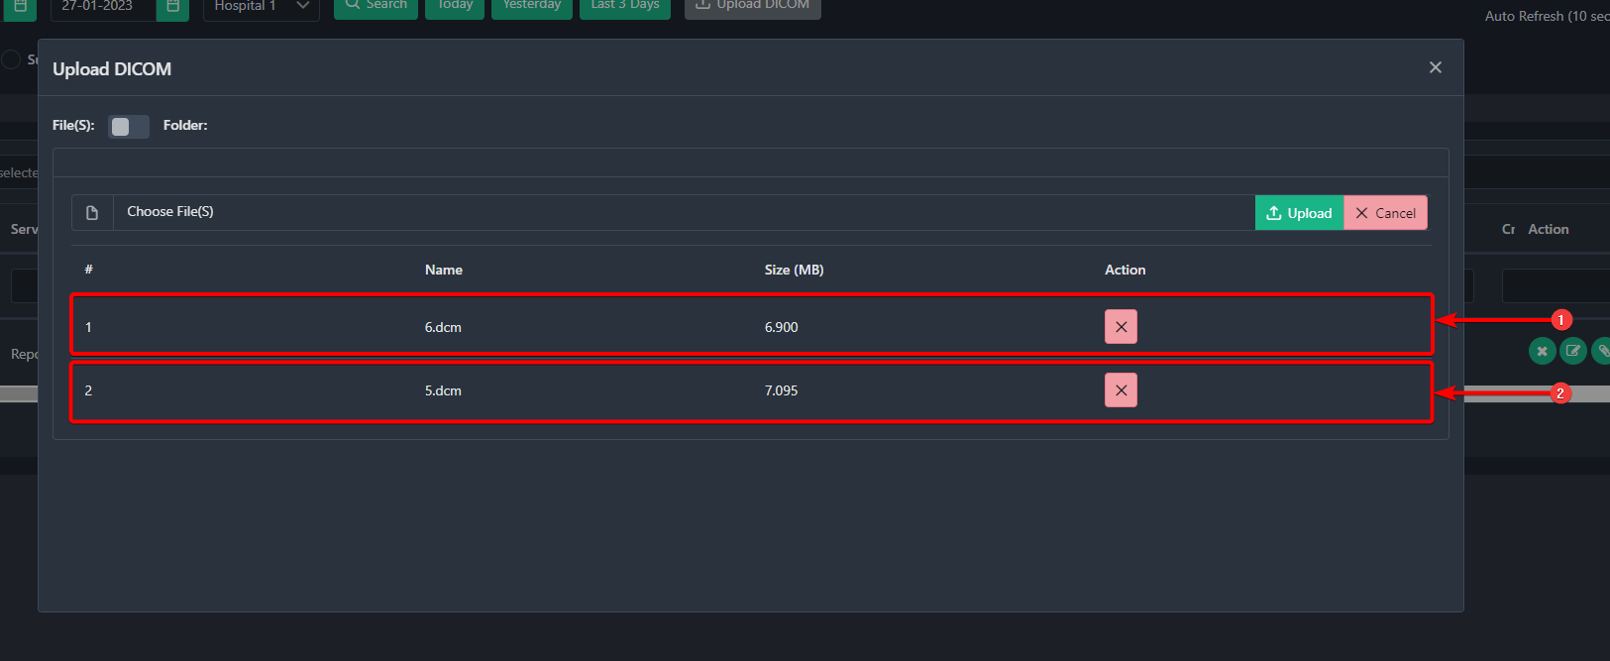
To Confirm your upload, click on the Upload [1] button. Or you can remove the file by clicking on the Cross Icons [2] or cancel the complete uploading process by clicking on the Cancel button [3].

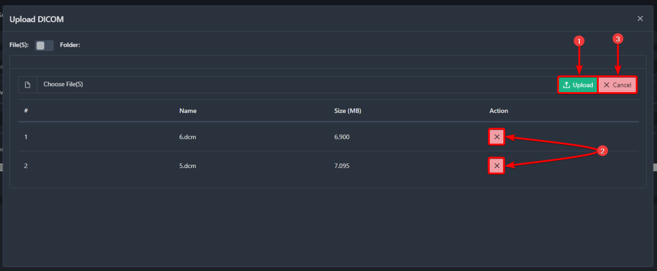

After clicking on the Upload button, you should see the study is created in the study worklist by collecting from the DICOM files you uploaded.
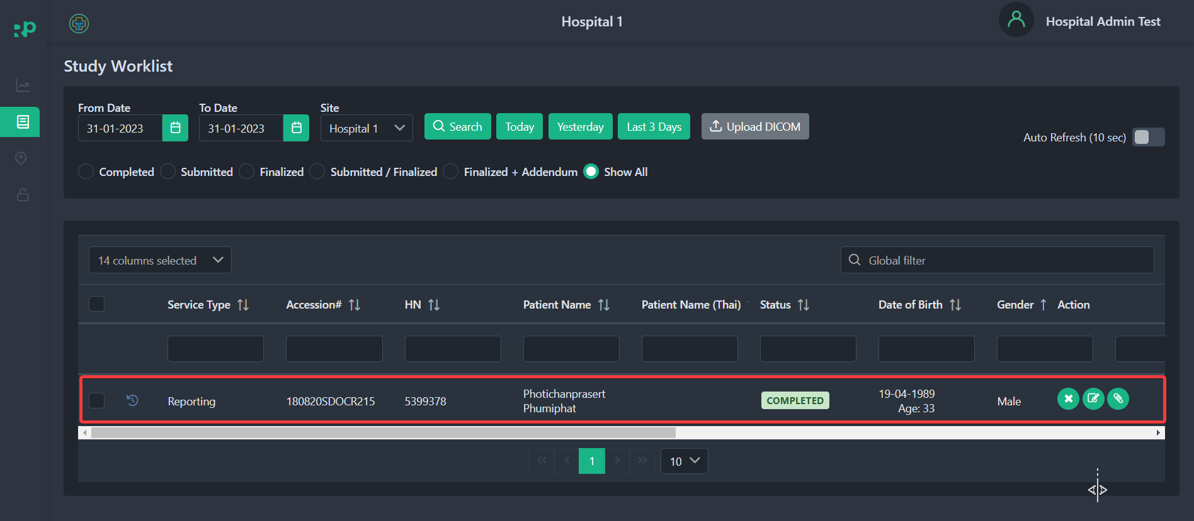

The newly uploaded study should have the status shown as Completed.
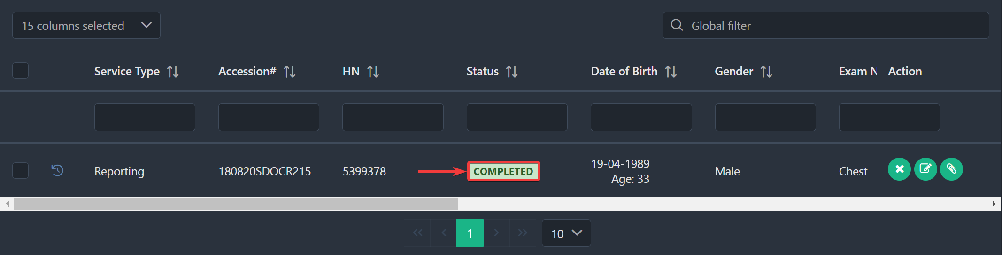

2.4 How to Organize Information of Studies
All information associated with a study or patient can be viewed from the study worklist.
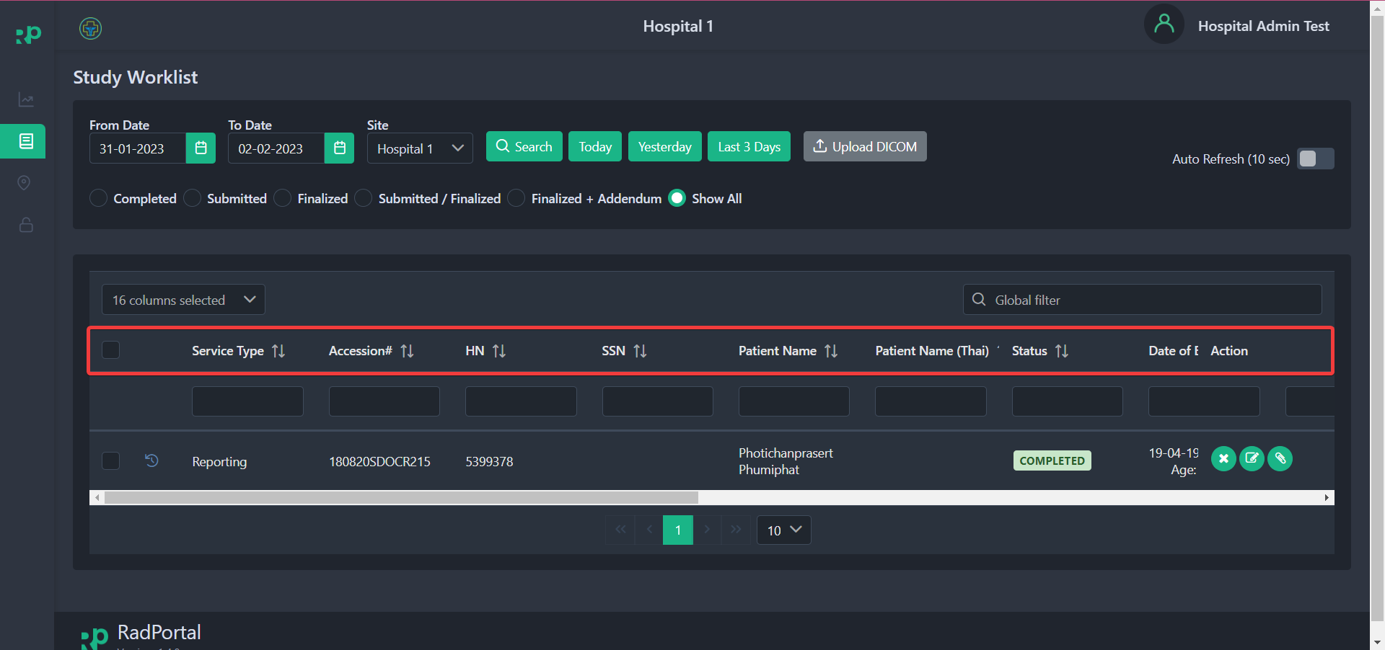

To activate an information type, click on Choose Columns [1] and find the information type you want to activate. To activate, click on the checkbox [2] before the information type.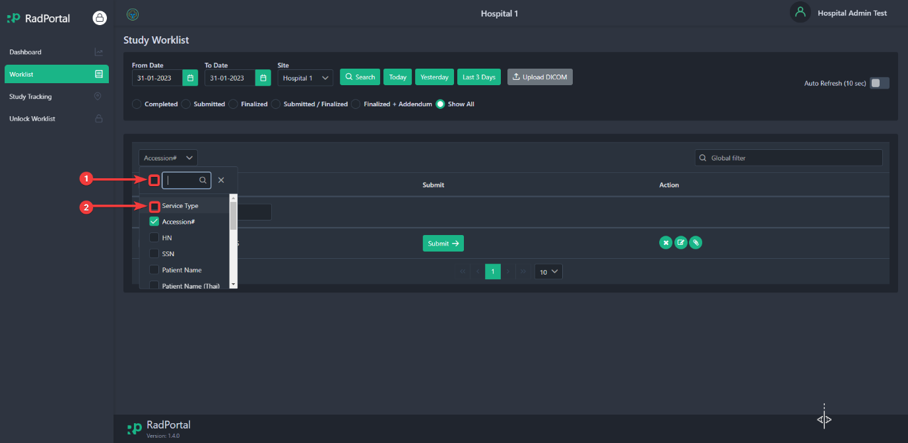

After selecting, you should see that the specific information type is now activated.
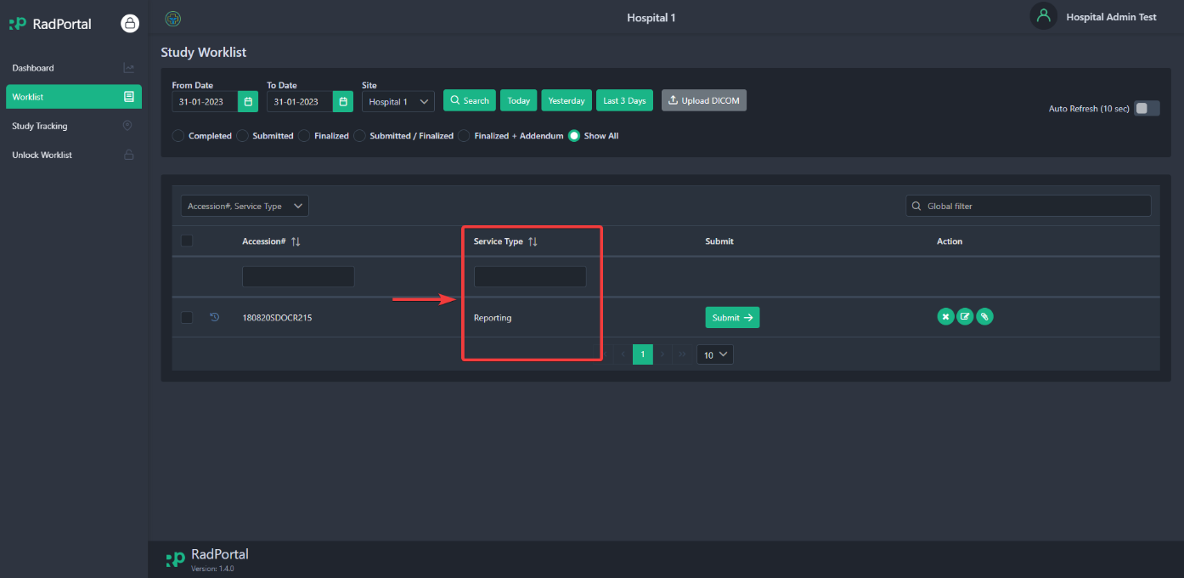

You can activate all information types by clicking on Choose Columns [1] and then clicking on checkbox [2] at the top of the dropdown.
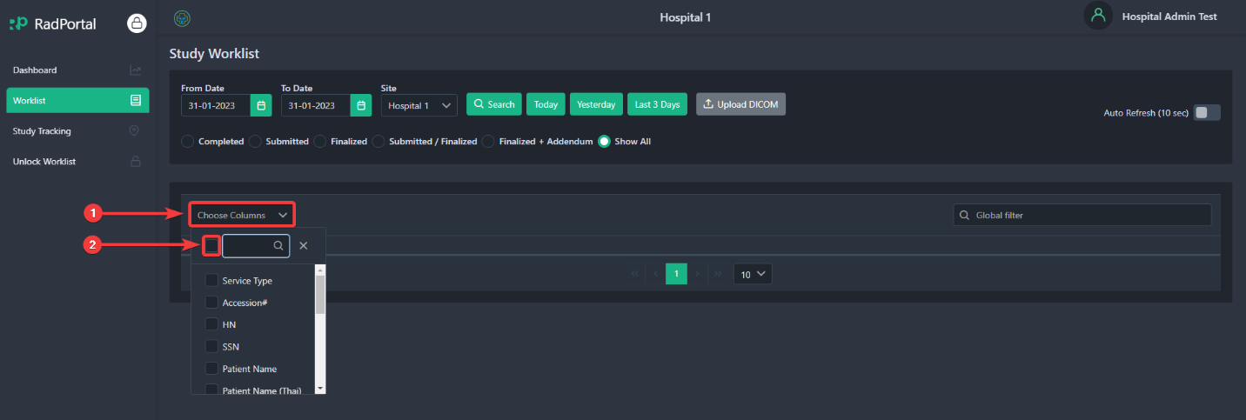

After clicking on the checkbox, you should see all information types are now activated.
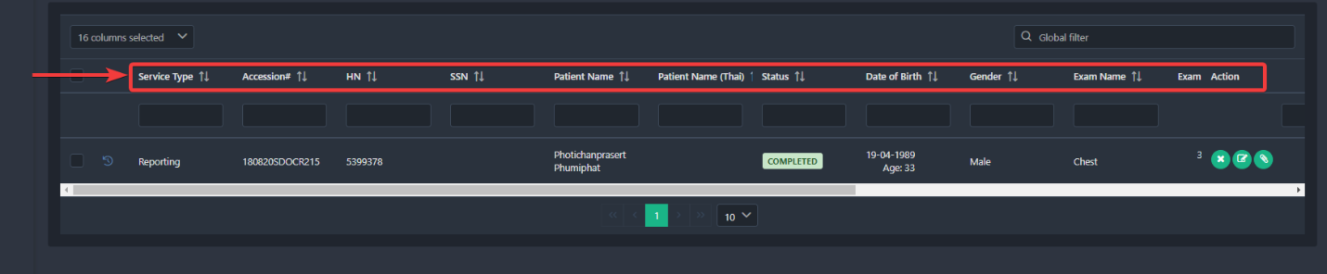

You can also search based on a specific information type by entering your search keywords in the blank fields.
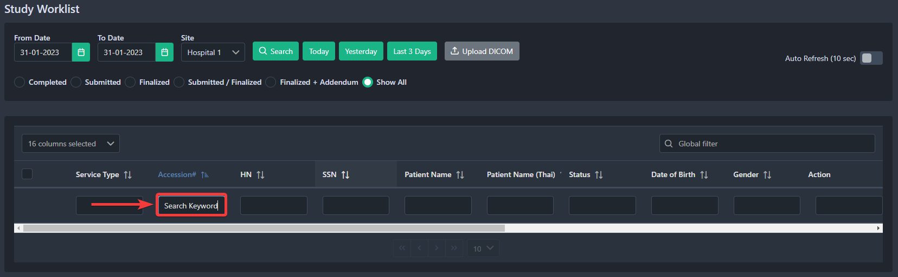

Currently, you can view 16 types of information that you can show in the study worklist page, such as:
Number  (By Order) | Field Name | Description
1 | Service Type | It shows the Service type being offered to the patient
2 | Accession Number | It is a unique identifier of a study for the RadPortal system.
3 | H.N. (Hospital Number) | It is a unique identifier generated on the hospital end.
4 | SSN | SSN is the patient's Social Security Number.
5 | Patient Name | It shows the patient's Name in English
6 | Patient Name (Thai) | It shows the patient's Name in the Thai language.
7 | Status | It shows the status of a particular case/study.
8 | Date of Birth | Shows the patient's date of birth.
9 | Gender | Show the patient's Gender.
10 | Exam Name | It shows the exam name of a case/study
11 | Exam Date | It shows the exam date of a case/study
12 | Image | It shows the total image count of a specific study.
13 | Created On | It shows the date the study was created
14 | Updated On | It shows the last update date of a particular case/study.
15 | Assigned To | It shows the Name of a radiologist assigned to a particular case/study
16 | Modality | It shows the test code (defined by the RadPortal system) of a particular case/study.

2.5 How to Delete/Cancel, Reconcile/Edit studies and attach additional files to studies

2.5.1 How to Delete/Cancel
Studies can be easily deleted from the RadPortal System. To remove studies, click on the Cancel button.
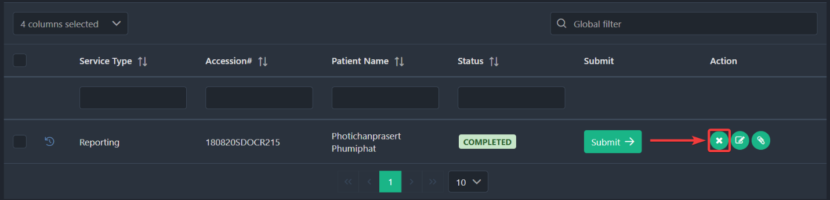

After clicking on the cancel button, you should see a popup window where you can specify the reason for deleting that particular study in the Reason [1] text field. To confirm the deletion of that study, click on the Yes [2] button, or if you do not want to delete the study, click on the No [3] button.
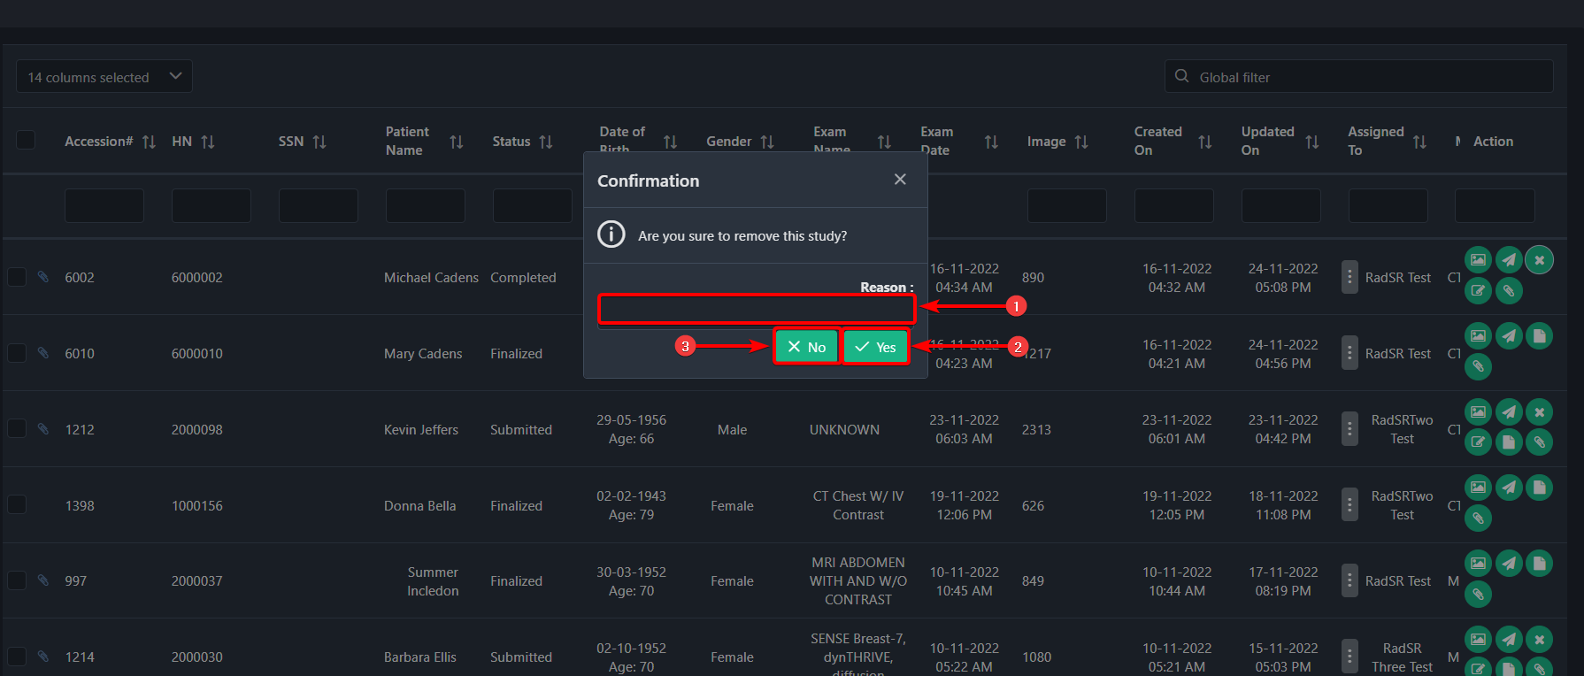

2.5.2 Reconcile/Edit Study
You can easily reconcile studies in the RadPortal. By default, the RadPortal system collects information from the DICOM Files. So, you may need to reconcile/edit studies to attach additional information. You can edit/add information such as SSN, HN, First Name, Middle Name, Last Name, Gender, Age, DOB, Accession No, Study Date, and Study Govt Code.
To reconcile a particular study, click on the Reconcile button ( ). You should see the reconcile button under the Action section of the study worklist.
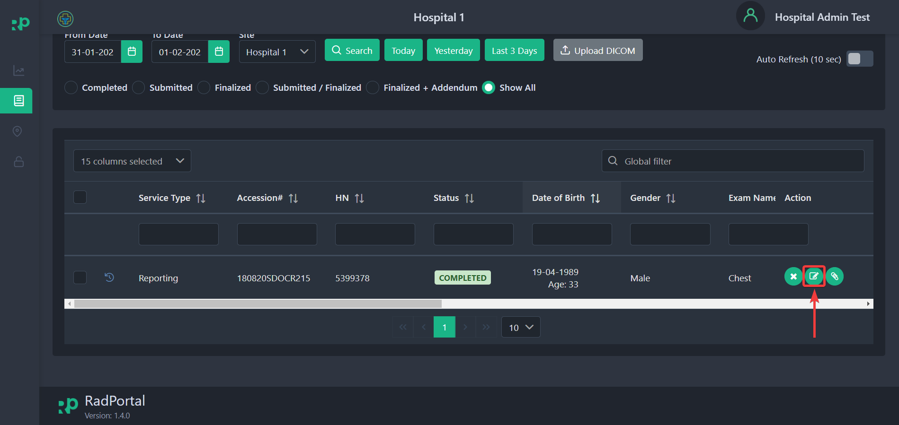
Note: You will be again asked to reconcile or edit patient information when you want to submit the studies.

After clicking, you should see a popup where you can edit or update patient and study information. When reconciling, you have to enter or reconfirm information such as Patient Type, Study Type, Turn Around Time, and Patient's SSN(Social Security Number), and in the study Information Section, select and add the global study, and Govt study Code
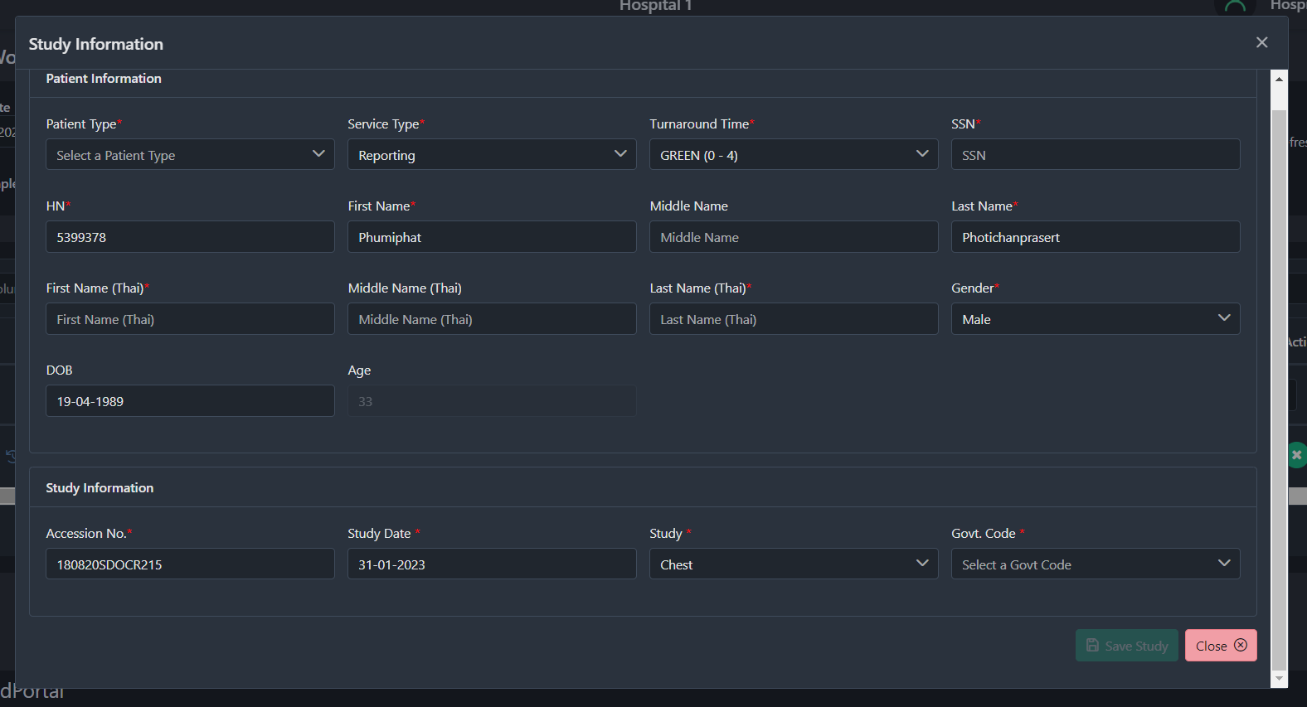

2.5.3 How to Add/Remove Documents
You can attach additional files to a study by clicking on the Document Upload button.
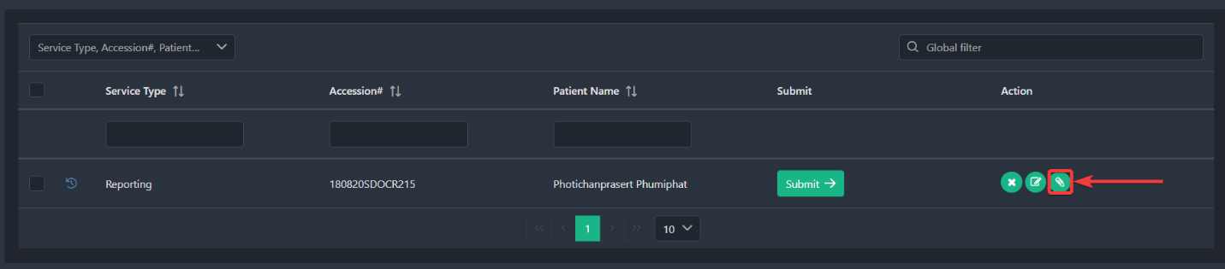

After clicking, you should see a popup window where you can define document Types [1] such as Report, Lab data, or Clinical diagnosis. Select the document from the local storage by clicking the Choose Files [2] button. Add the Name of the document you just uploaded in the Title Field [3], and finally, click on the Upload button [4].
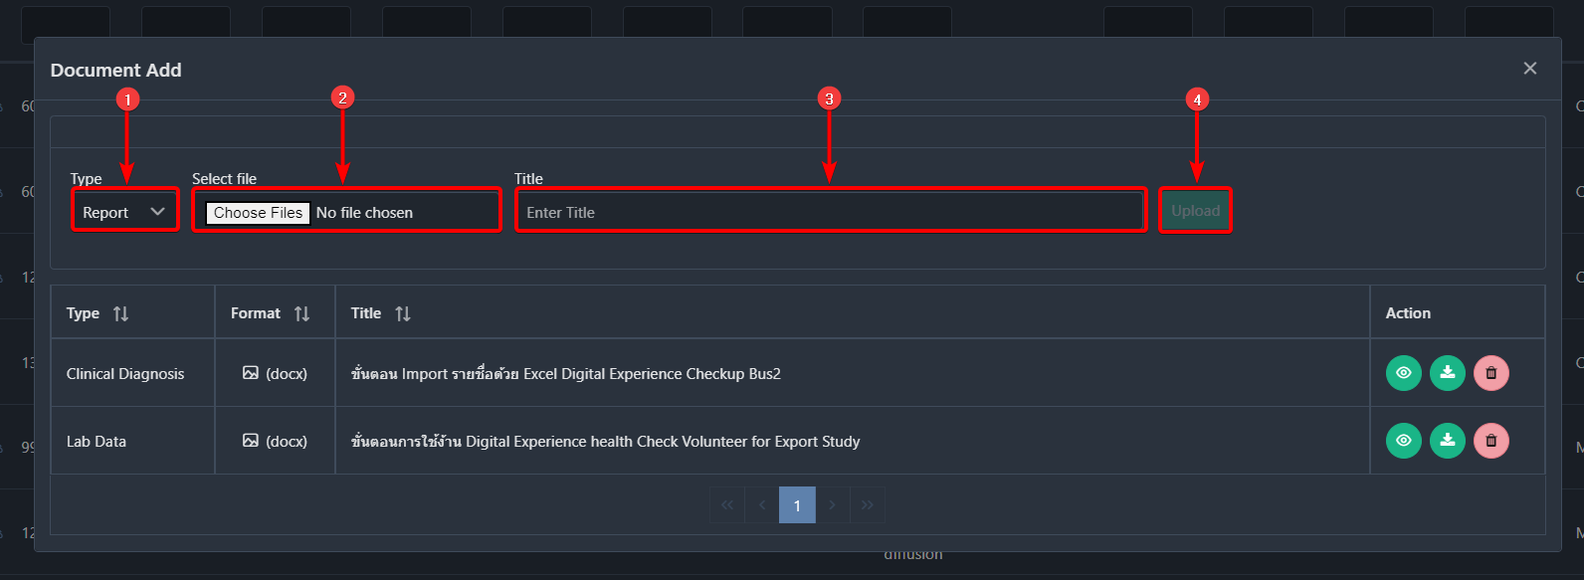

After completing the upload process, you should see the document in this list.
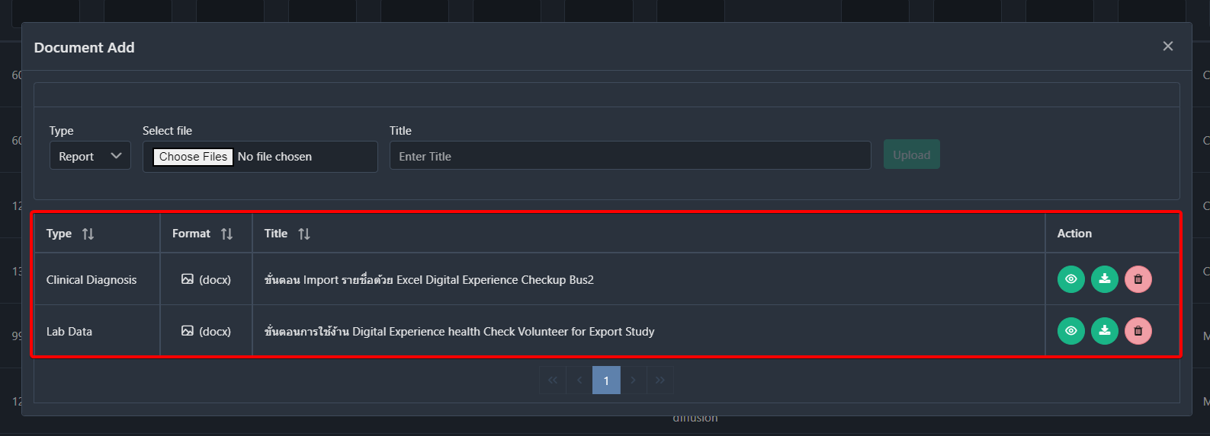

You can view, download or delete the document by clicking on the View [1], Download [2], and Delete [3] buttons.
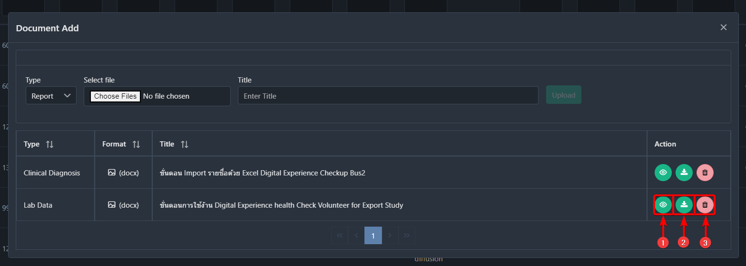

2.6 How to Submit studies
When a DICOM Routers Uploads DICOM images or you(Healthcare Service Provider Admin) uploads studies Manually, you should see them as studies in the worklist with the status of Completed. You have to submit the Study/Case before the studies get assigned to a radiologist. After you submit a study, it will automatically be sent to the PACS (Picture Archiving and Communication System).
After you upload a DICOM file and a study is created, you have to select and add some information to the studies before you submit the studies to the customer.
To add the required information, click on the Submit button under the submit information type.
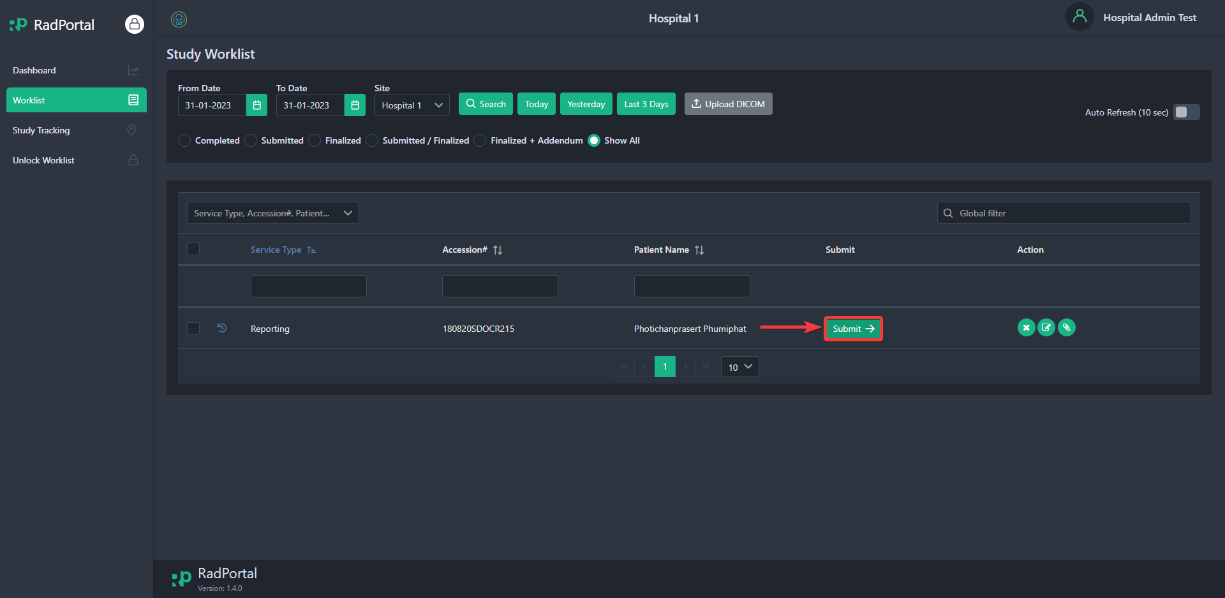

After clicking, you should see a popup window like the page below
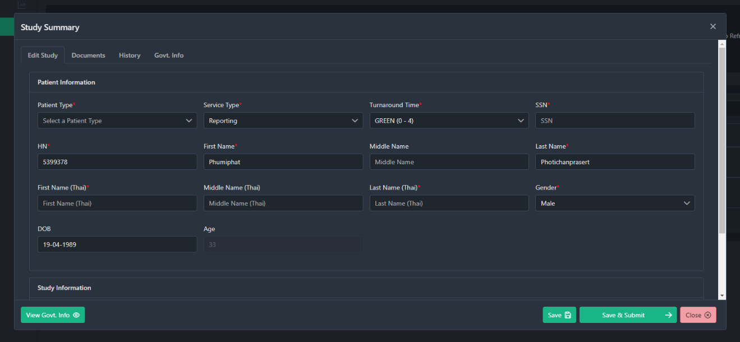

On this window, you can see there are 4 tabs.
- Study Edit
- Documents
- History
- Govt. Info

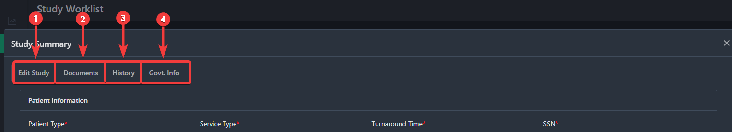

In the next few sections, you will see how you can add information before you submit the study.

2.6.1 Edit Study
In this section, you have to fill in information about the study. You have to fill in information such as Patient Type[1], Service Type[2], Turnaround Time[3], SSN[4], HN[5], First Name*[6], Middle Name[7], Last Name*[8], First, Name (Thai)*[9], Middle Name (Thai)[10], Last Name (Thai)*[11], Gender*[12], DOB[13], Accession No.*[14], Study Date*[15], Study*[16], and Govt. Code*[17].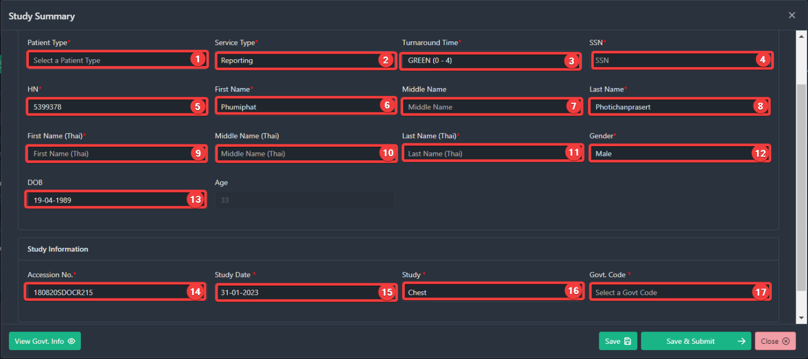
Note: You have to fill in fields containing (*) before you try to submit the study.

Patient Type[1]
In this field, you can choose the type of patient. You can choose between options such as IPD and OPD.
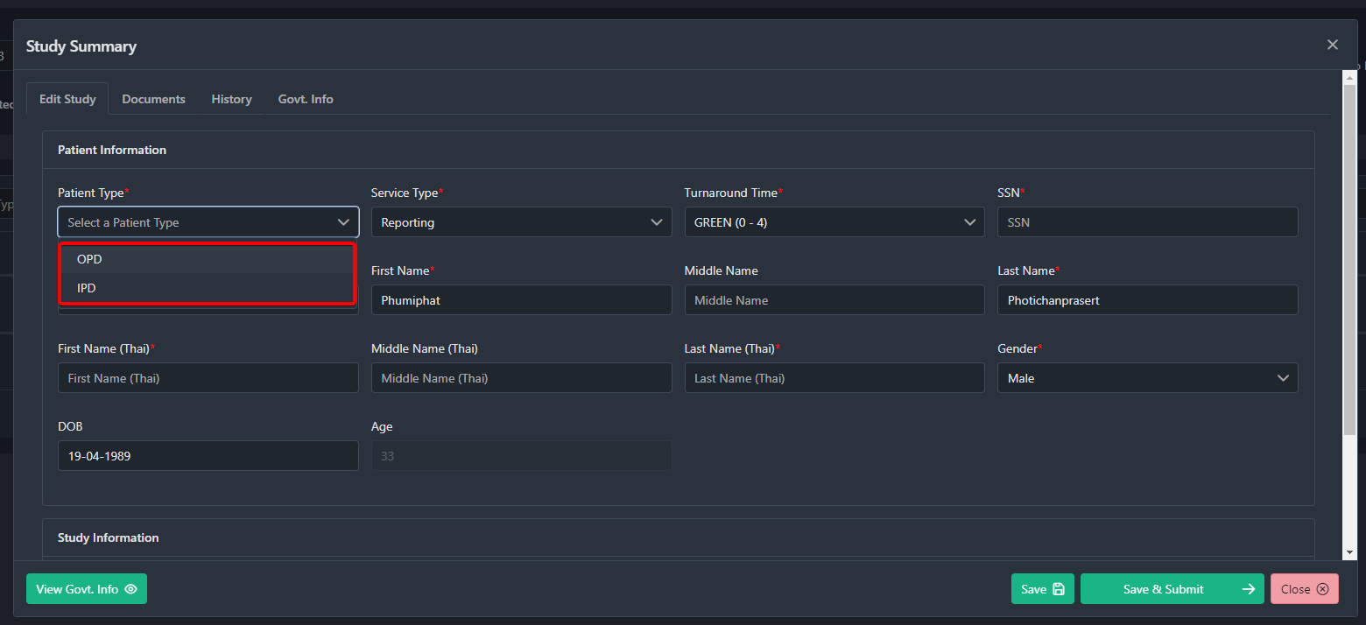

OPD(Outpatient Department): OPD type refers to patients who are not admitted or hospitalized or don't requires an overnight stay but still receive medical treatments or care at a hospital. Outpatients visit a hospital for appointments, tests, or procedures and can go home the same day.
IPD(Inpatient Department): IPD type refers to the patients who are admitted or hospitalized and require an overnight stay or a more extended period of hospitalization.

Service Type[2]
In this field, you must choose the study's service type. You can choose between Reporting, Consulting, and Consulting Complex Cases.
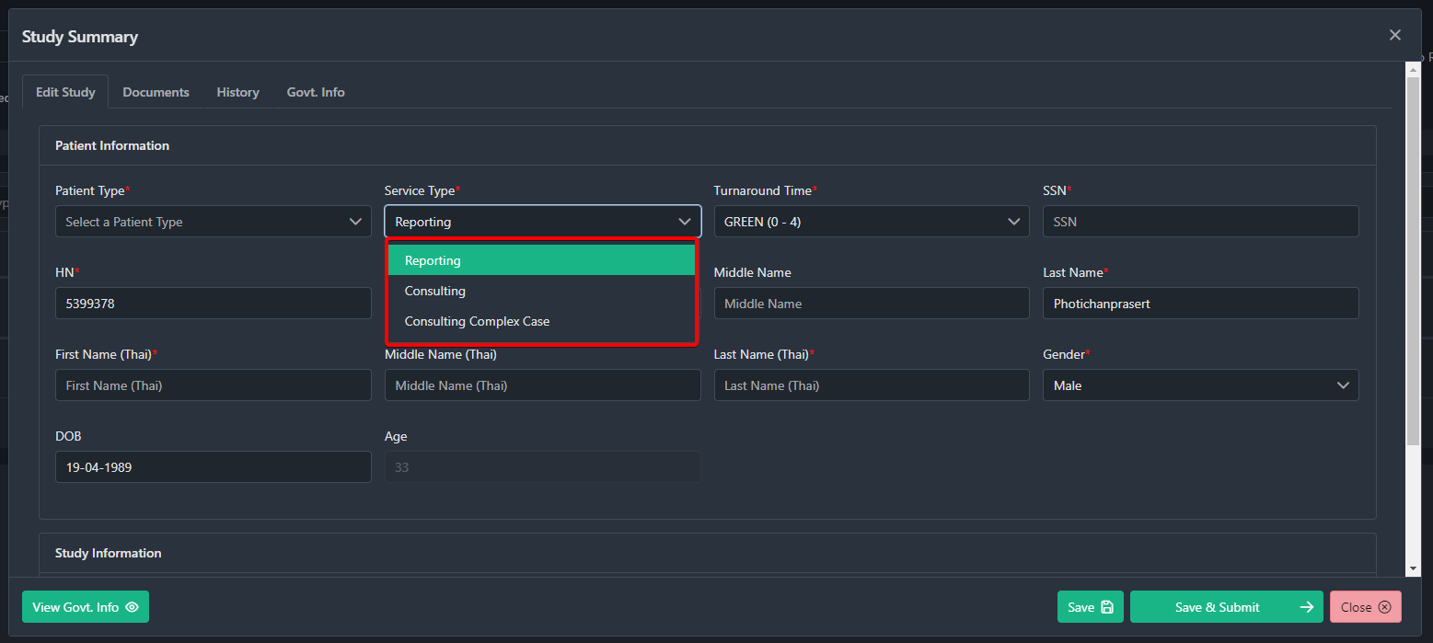

Reporting means the basic interpretation of radiological test images, while Consulting and Consulting Complex cases involves more extensive involvement between the radiologist and healthcare provider. Radiologists only provide a report for Reporting studies and scores for Consulting studies and both scores and complexity ratings for Consulting Complex studies.

Turnaround Time[3]
Turnaround time refers to the time it takes for a Radiologist to prepare a written report or interpretation of the radiological images. Currently, You can choose (0 - 4), (4 – 6), (6 - 8), and (min 8), and they are color labeled subsequently as GREEN ORANGE YELLOW, and RED
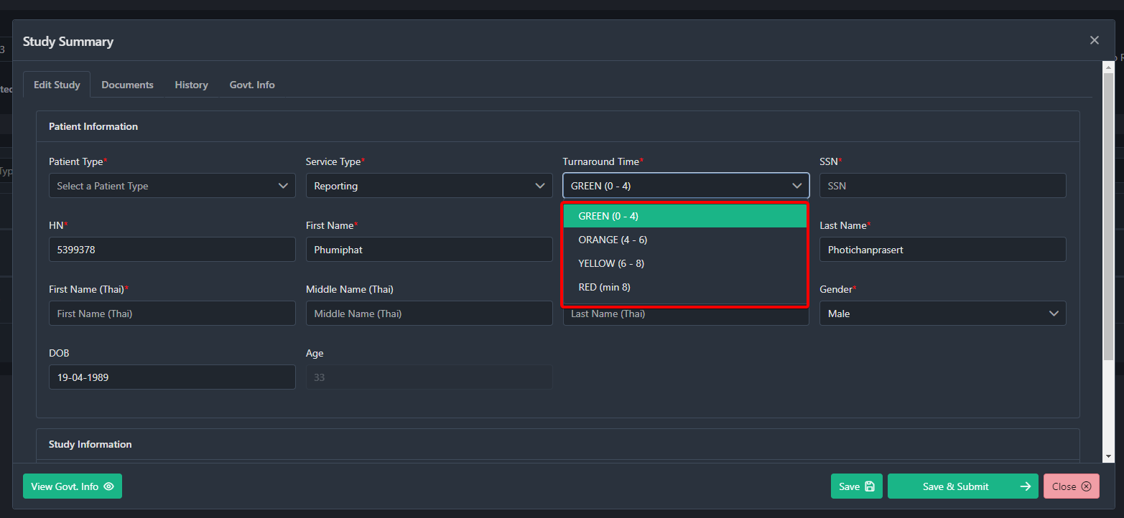

Accession No[14]
Accession Number is a unique identifier in the RadPortal. In this field, you can add a custom Accession number. This Number is used to track and manage the studies.

Study[16]
This study code refers to the modality test name.

Govt. Code[17]
This Govt. Code refers to a generalized information format acknowledged by government institutes.

2.6.2 Documents
You can attach additional files to a study by clicking on the Documents Tab.
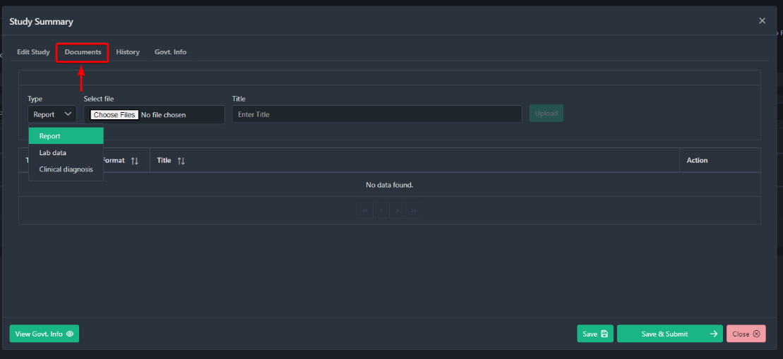

After clicking, you should see a popup window where you can define document Types [1] such as Report, Lab data, or Clinical diagnosis. Select the document from the local storage by clicking the Choose Files [2] button. Add the Name of the document you just uploaded in the Title Field [3], and finally, click on the Upload button [4].



After completing the upload process, you should see the document in this list.


You can view, download or delete the document by clicking on the View [1], Download [2], and Delete [3] buttons.


2.6.3 History
History is created when a patient completes their radiological test for the second time. To review the history of the specific study, click on the History tab. 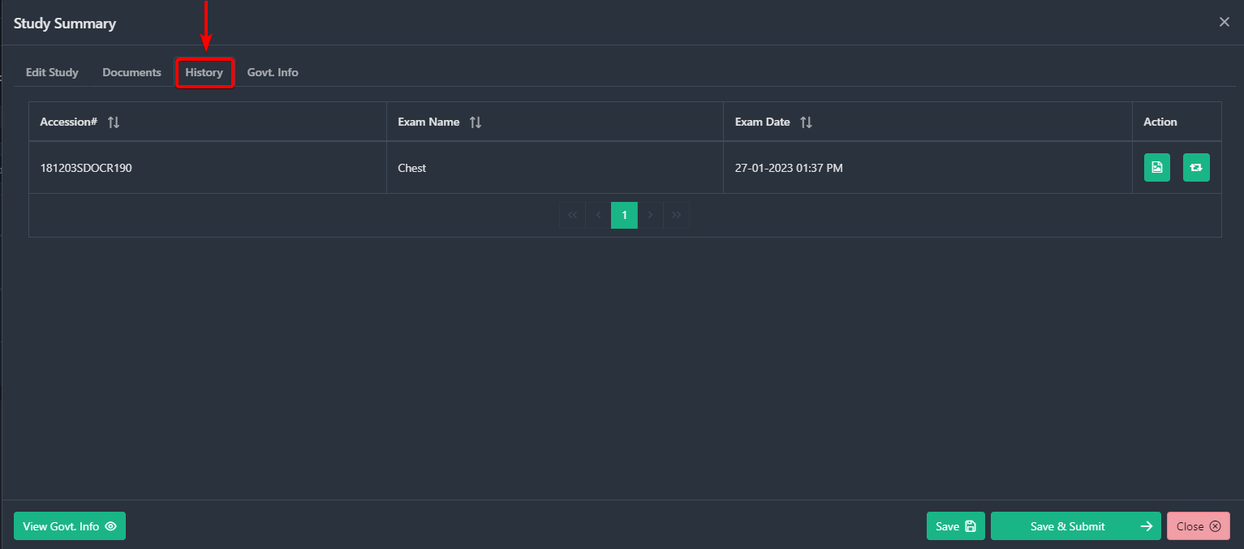

After clicking, you should see all previous history studies for the specific study you want to submit.
You can review the historical images and findings of a specific history study by clicking on the Image() icon.
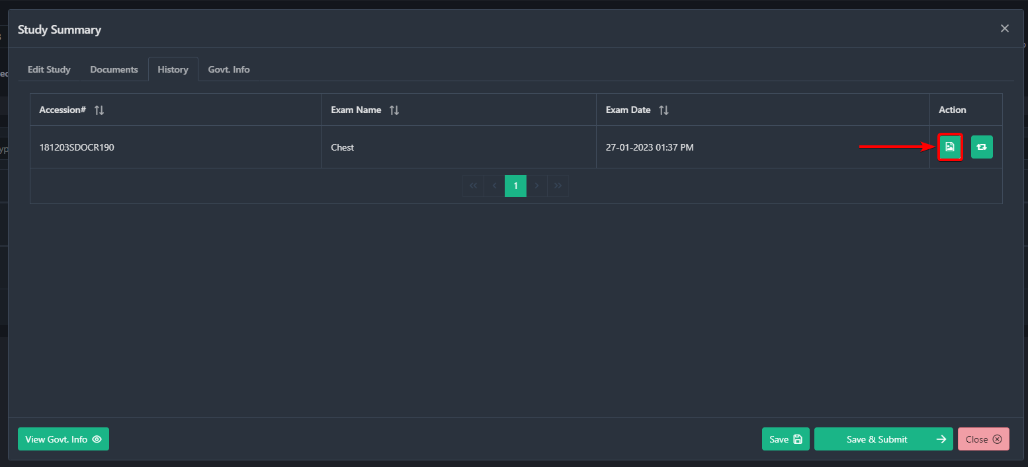

After clicking, you should see the history study images. 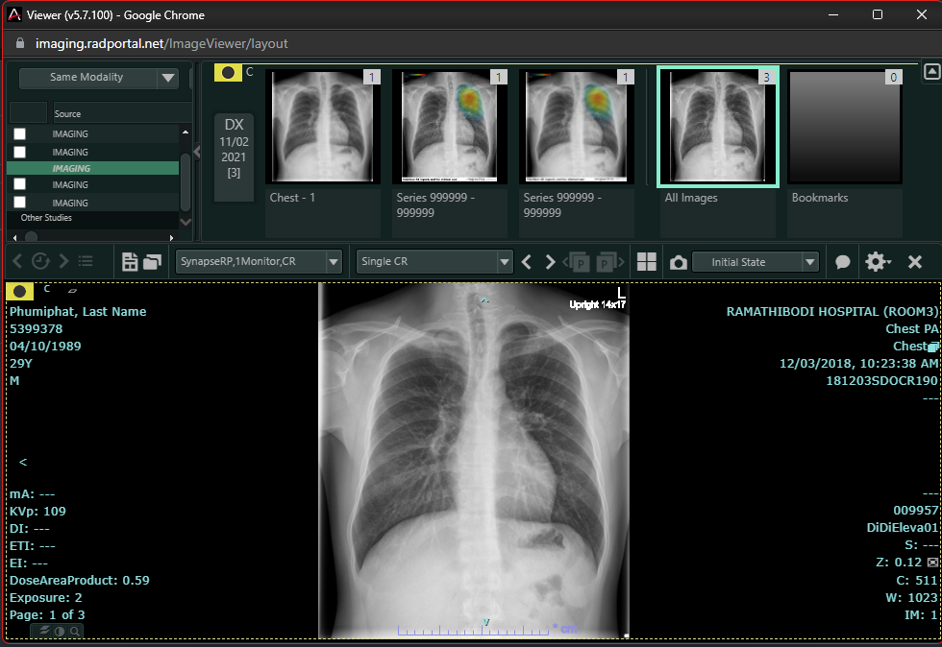

You can convert the history study to the Main study by clicking on this() Icon.
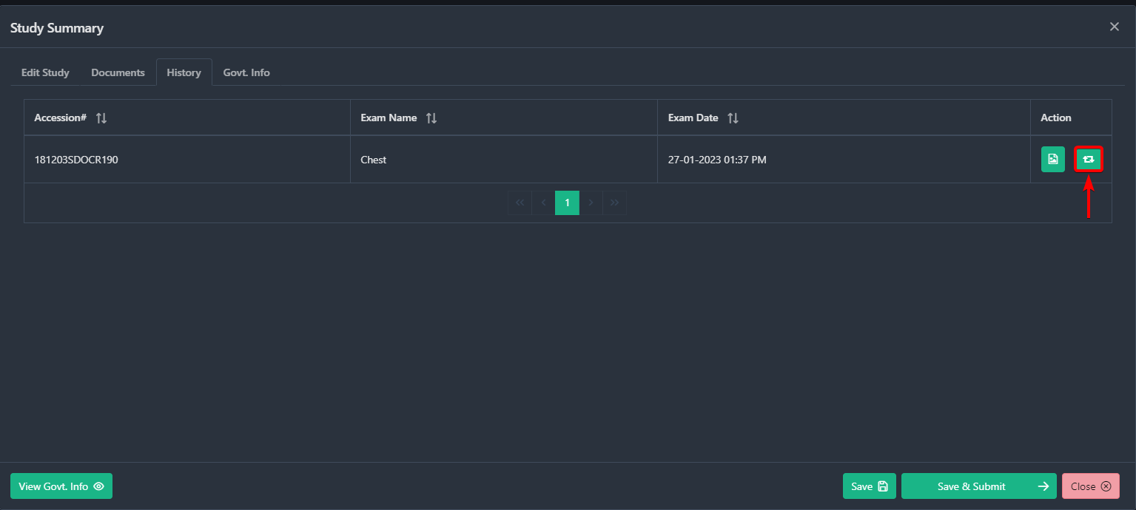

2.6.4 Information to add in the Govt Info
There are 8 types of information you have to add. These types are:
- General
- ADP
- AER
- INS
- ODX
- OOP
- ORF
- PAT

2.6.4.1 General
Patient Type In this field, you can choose the type of patient. You can choose between options such as IPD and OPD.

OPD(Outpatient Department): OPD type refers to patients who are not admitted or hospitalized or don't require an overnight stay but still receive medical treatments or care at a hospital. Outpatients visit a hospital for appointments, tests, or procedures and can go home the same day.
IPD(Inpatient Department): IPD type refers to the patients who are admitted or hospitalized and require an overnight stay or a more extended period of hospitalization.
SSN
Accession

2.6.4.2. ADP
TYPE
The options under types are:
- H.C. (OPD)
- Instrument (Category 2)
- Other service fees Uncategorized
- Promotional/Preventive Fee/Specific Services
- Project code 6 = Protocol Cancer Treatment
- Radiology Cancer Treatment
- OP REFER and Fee Schedule (can be named TYPE or TYPEADP)
- Diagnosis by other special methods (Category 9)
- Room/food (Category 1)
- Non-drug medical supplies (Category 5)
- Dental service fee (Category 13)
- Acupuncture service fee ( Category 15)
- Blood and Blood Components Service (Category 6)
- Technical Medical and Pathological Diagnosis (Category 7)
- Radiology Diagnosis and Treatment (Category 8)
- Nursing Service Fee ( Category 12)
- Medical equipment and tools (Category 10)
- Procedure and Anesthesia (Category 11)
- Fees for physical therapy and rehabilitation (Category 14)

Code
The Code specified by the NHSO can enter the Code according to the conditions. pending (wait for CODE code from NHSO about 1-2 weeks)
Qty
The unit is the number of times or the Number of pills of the therapeutic device and the number of pills used. Pending (waiting for Code from NHSO)

Rate
Unit Price pending (waiting for Code from NHSO)

2.6.4.3. AER
Refer No
OREFTYPE

2.6.4.4. INS
INSCL
Treatment rights used
CID
Card number to check. ID card code according to the Department of Provincial Administration.

2.6.4.5. ODX
DATEDX
Date, month, year of diagnosis, a record year in A.D.
DIAG
Diagnosis according to ICD 10 code
DXTYPE
Type of disease, specify
- Primary Diagnosis
- Comorbidity
- Complication
- Others
- External Cause
DRDX
physician according to the number of professional medical licenses

2.6.4.6 OOP
OPER
DROPID

2.6.4.7 ORF
REFER
The Code of the hospital or clinic associated with the referral.
REFERTYPE
Forwarding Type (1 = Incoming, 2 = Outgoing)
REFERDATE
forwarding date

2.6.4.8 PAT
Nation:
Nationality of the patient.
Person ID:
I.D. code according to the Civil Registration Office
ID TYPE:
ID Card types are
- ID card
- Passport
- Alien Book
- Books / other documents
- Foreigner Sor. Cover Card

Patient Name
It shows the patient's Name
First Name
It shows the first name of the patient's Name

Last Name
It shows the last name of the patient's Name
Title

2.6.4.9 OPD
UUC
- Exercise 1
- Exercise 2
- No exercise
- No withdrawal requests
TYPEIN
Type of service
- Come to pick up the service yourself
- Come to pick up the service by appointment
- Referral from another hospital
- Received by EMS service
TYPEOUT
Patient status upon completion of service
- Sold back home
- Received for I.P. treatment
- Refer to
- Died
- Died before arrival
- Died during transmission to another location
- Refuse treatment
- Run away

To view all government info, click on the View Govt. Info.
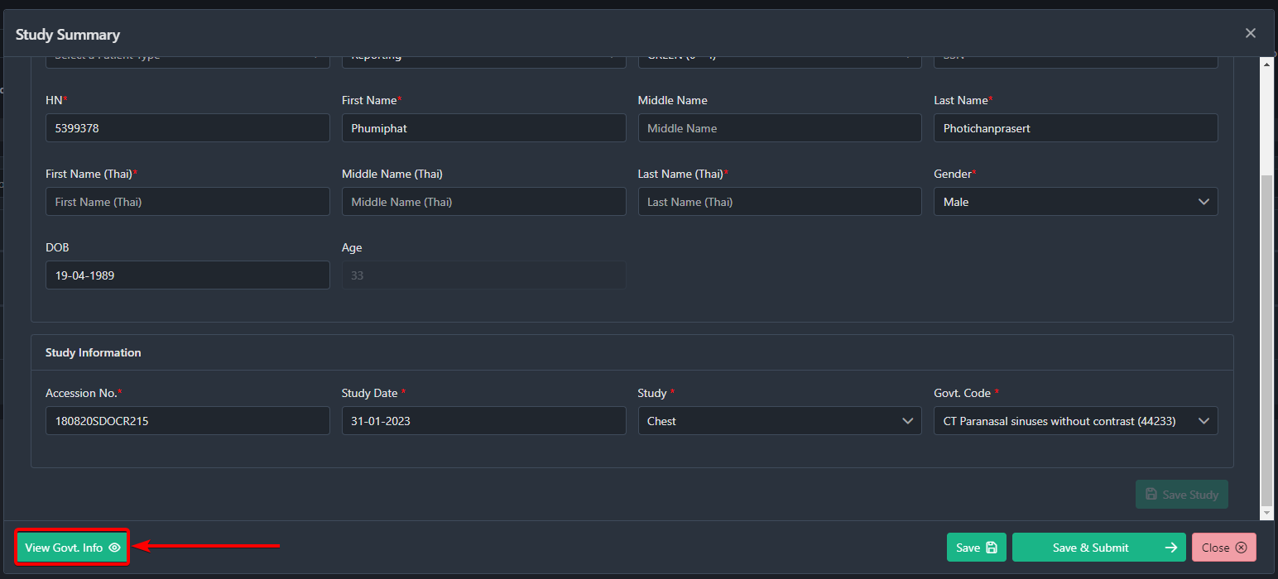

Finally, you can submit the study after filling in all the required fields. To submit the study, click on the Save & Submit button. 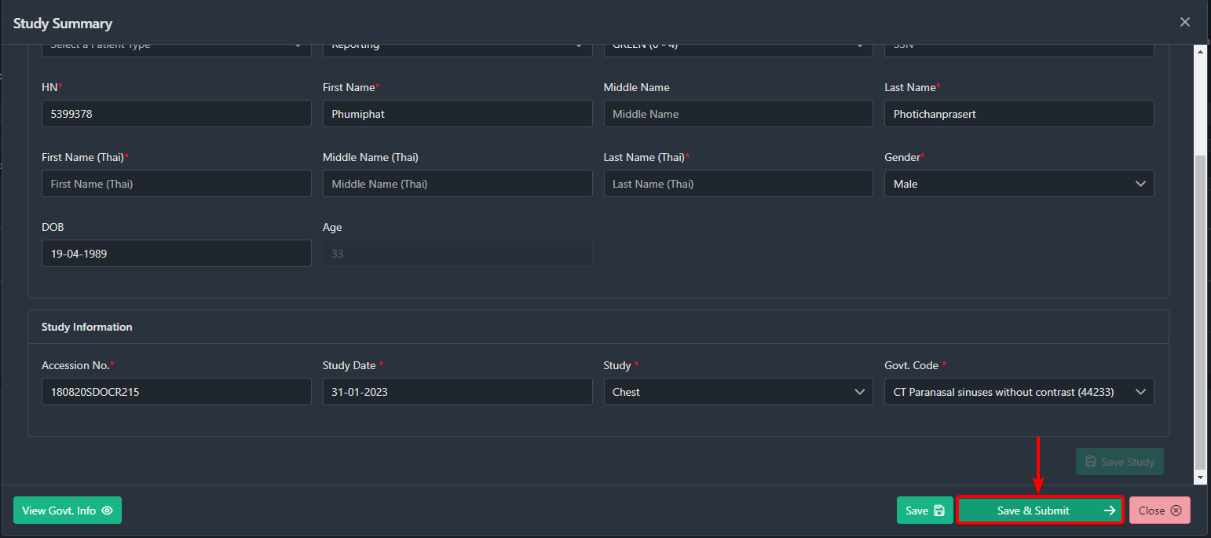

If you want to save all you entered without submitting the study, click on the Save button. 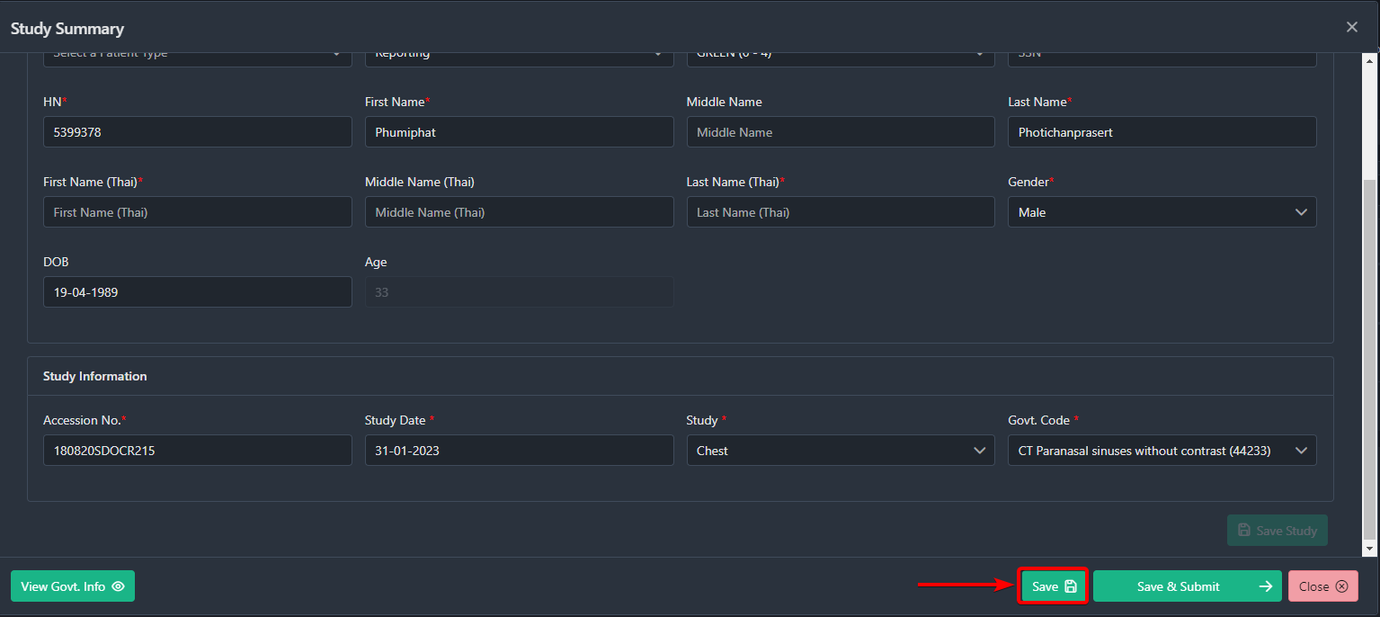

To exit without saving, click on the Close button. 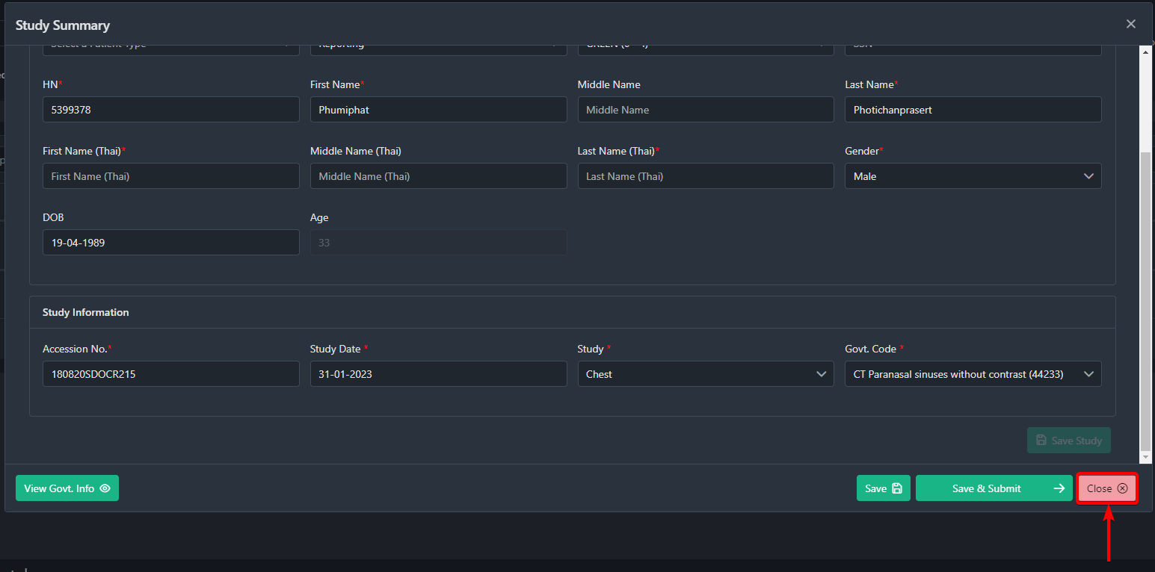

2.7 View Study Reports
After a radiologist has finalized a report of a study, you can view it by clicking on the File Icon
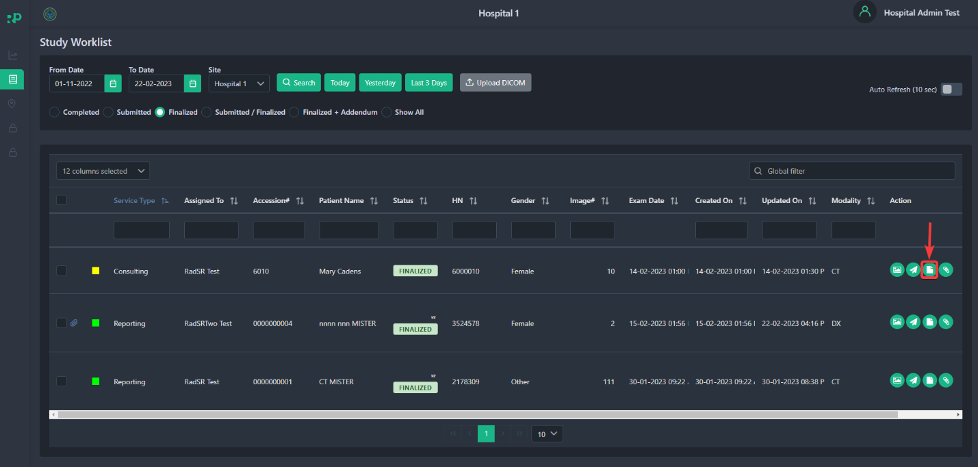

After clicking a window should pop up where you should see the finalized report of that specific study.
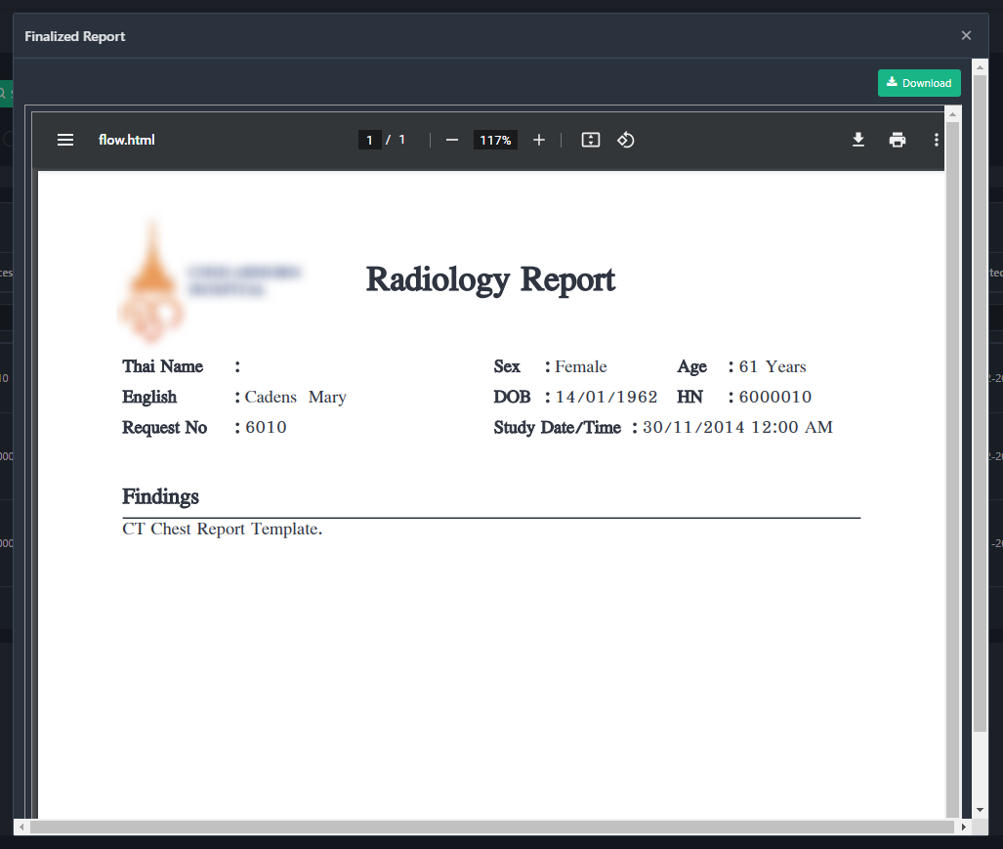

On this popup button you can download or Print the finalized reports by clicking on the Download[1] and Print[2] button.
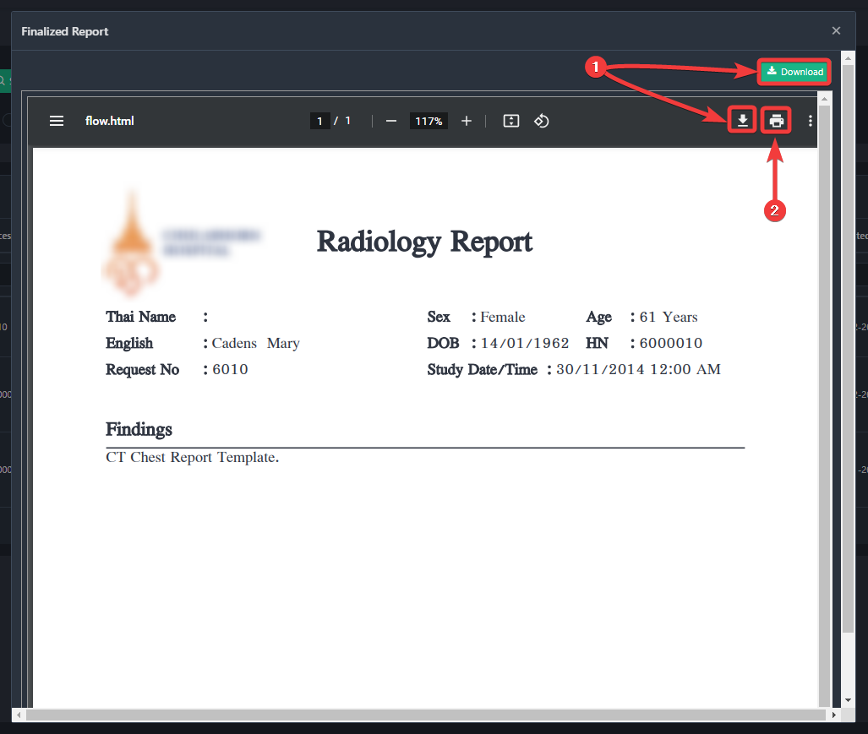

2.8 How to Delete/Cancel Studies
After you upload a DICOMS and a study is created, you can delete the study by clicking on the Cross Button.
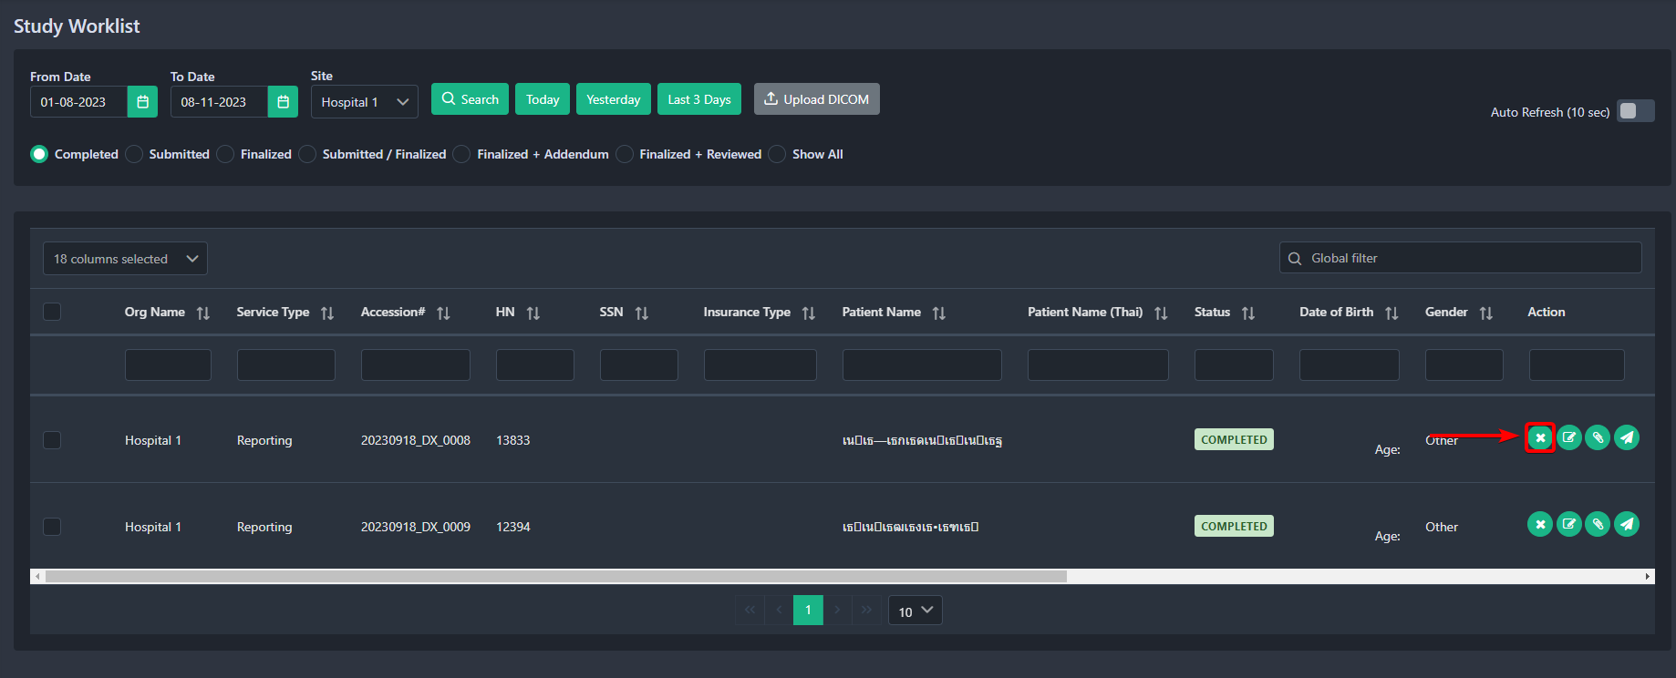

After clicking, you should see a confirmation popup window. You can enter the reason for cancellation in the Reason text field [1] or click the No [2] button to stop the decline process which will take you back to the study worklist page. Click on the Yes[2] button to decline the case.
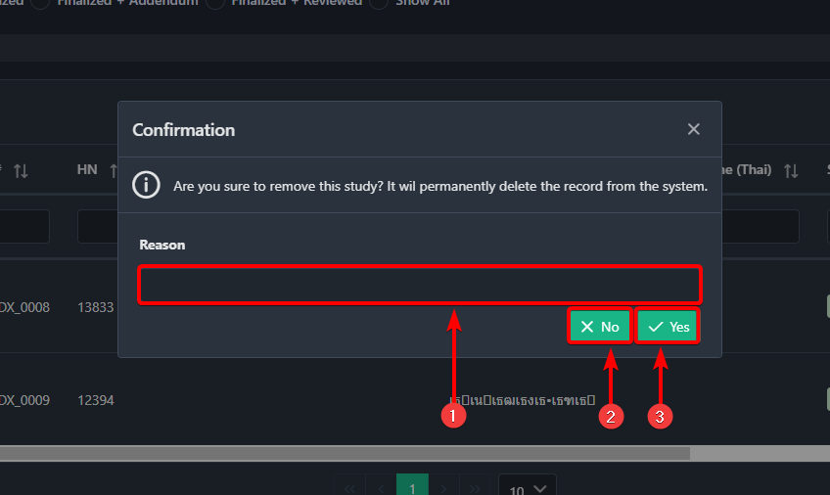

2.9 How to Review Finalized Reports Submitted by Radiologist
After the radiologist has finalized, the study will see the study status as Finalized. 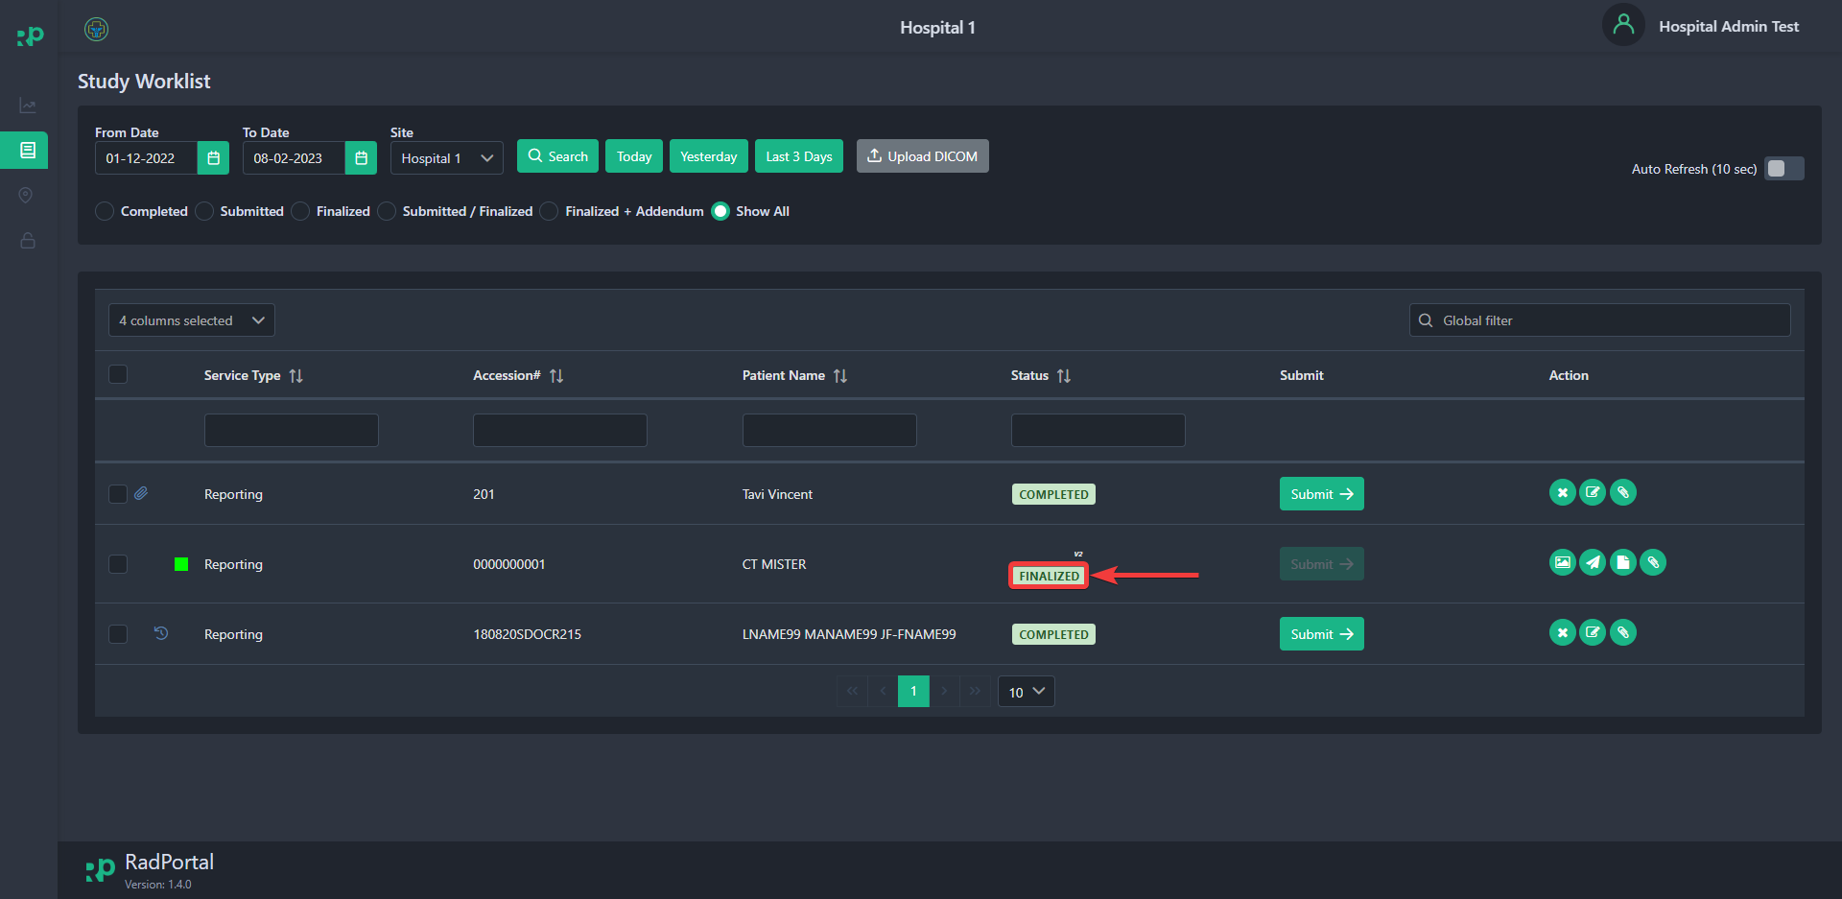

The Finalized Studies will have a View Report button under the Action section. To view reports, click on the View Report button.
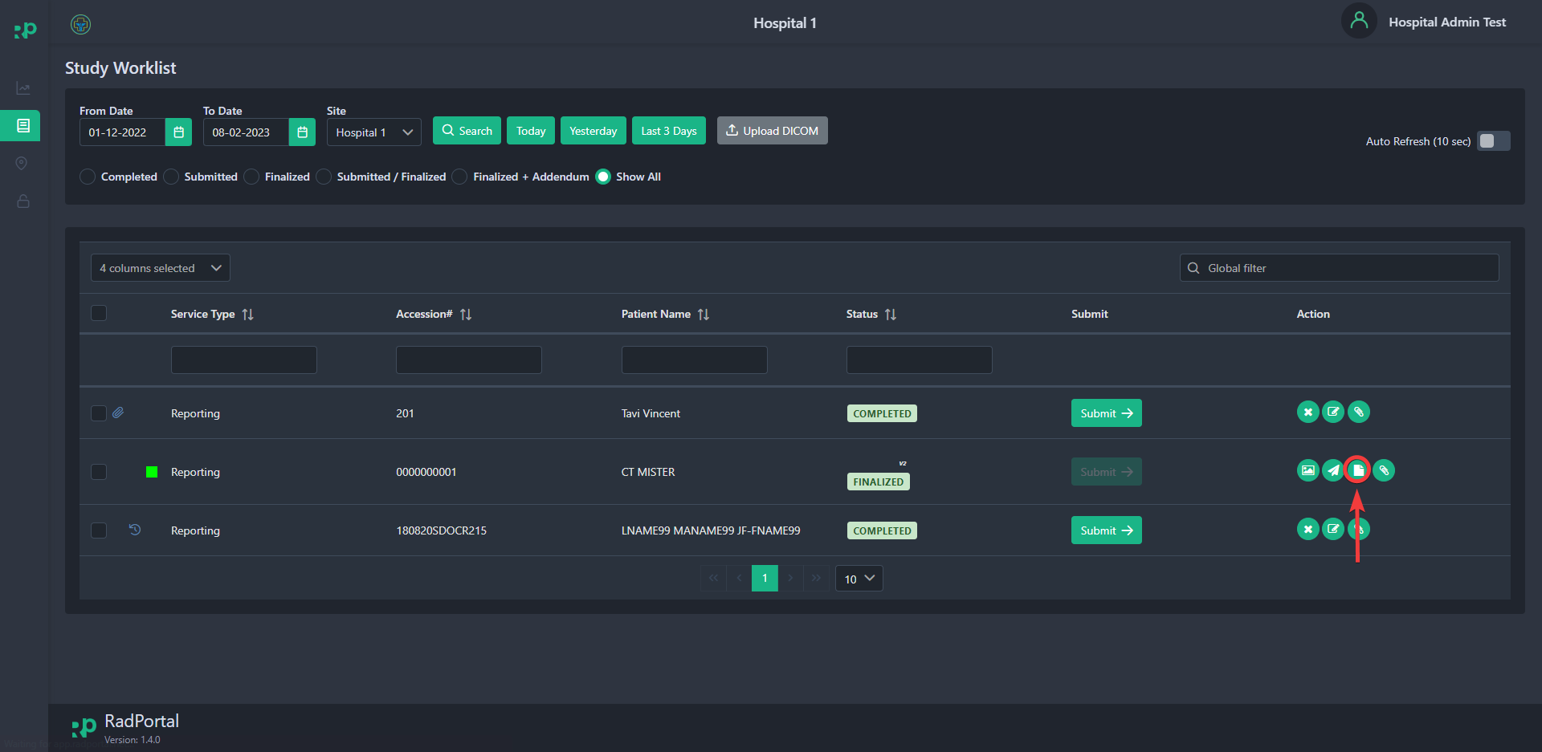

After clicking on the View Report, You should see a new window where you can view the report, addendums, rating, and scores. 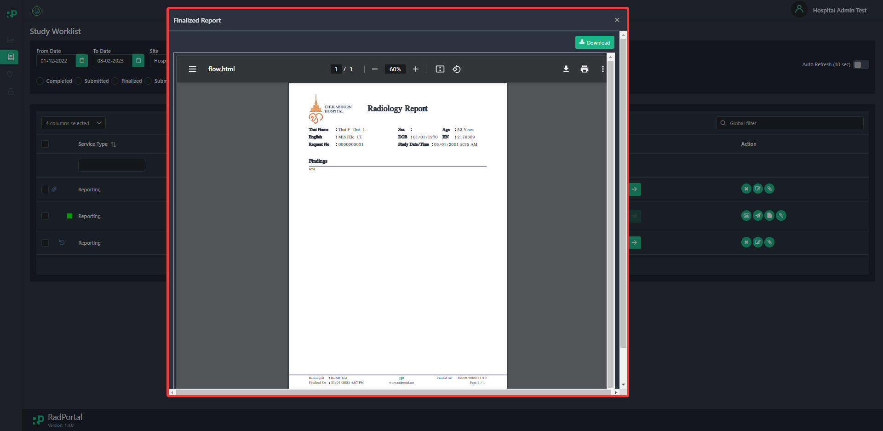

You can now download or print the report by clicking the Download Button[1] and Print Icon[2]. 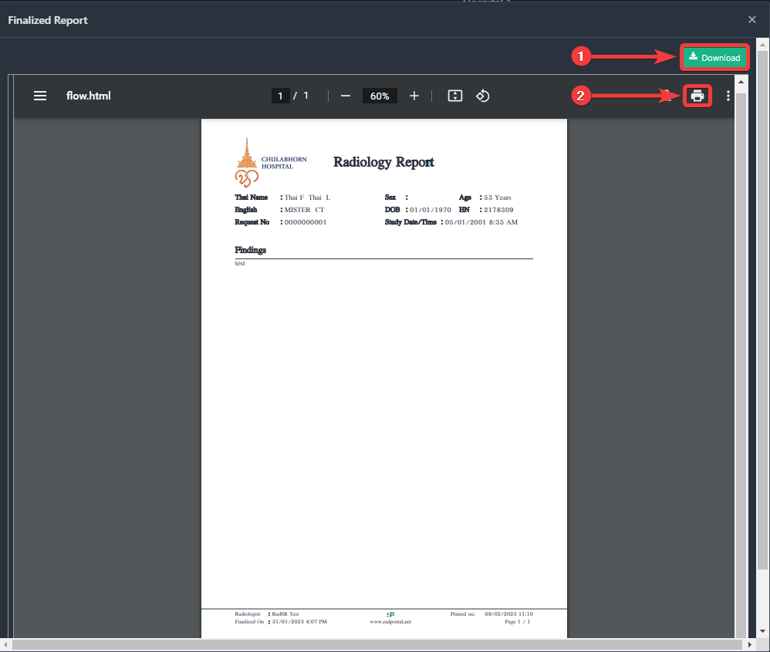

You can review the Finalized reports as well. To review click on the review button you see on the Study Worklist.
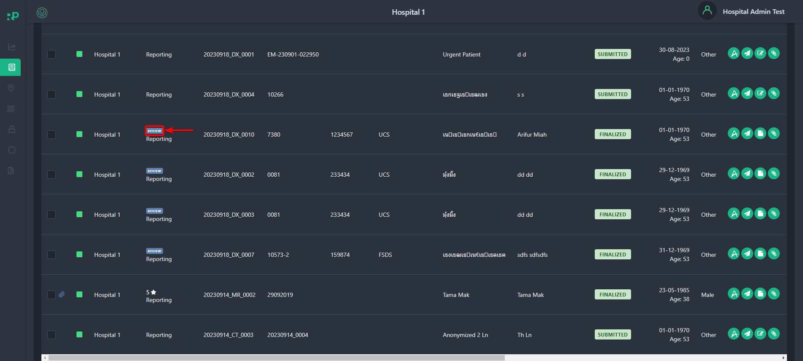

After clicking the Review button you should see a popup window where you can submit review(up to 5 starts) like On-time Delivery, Quality of Report, Platform Support and you can write Review Details. Finally, click on Submit to confirm the review.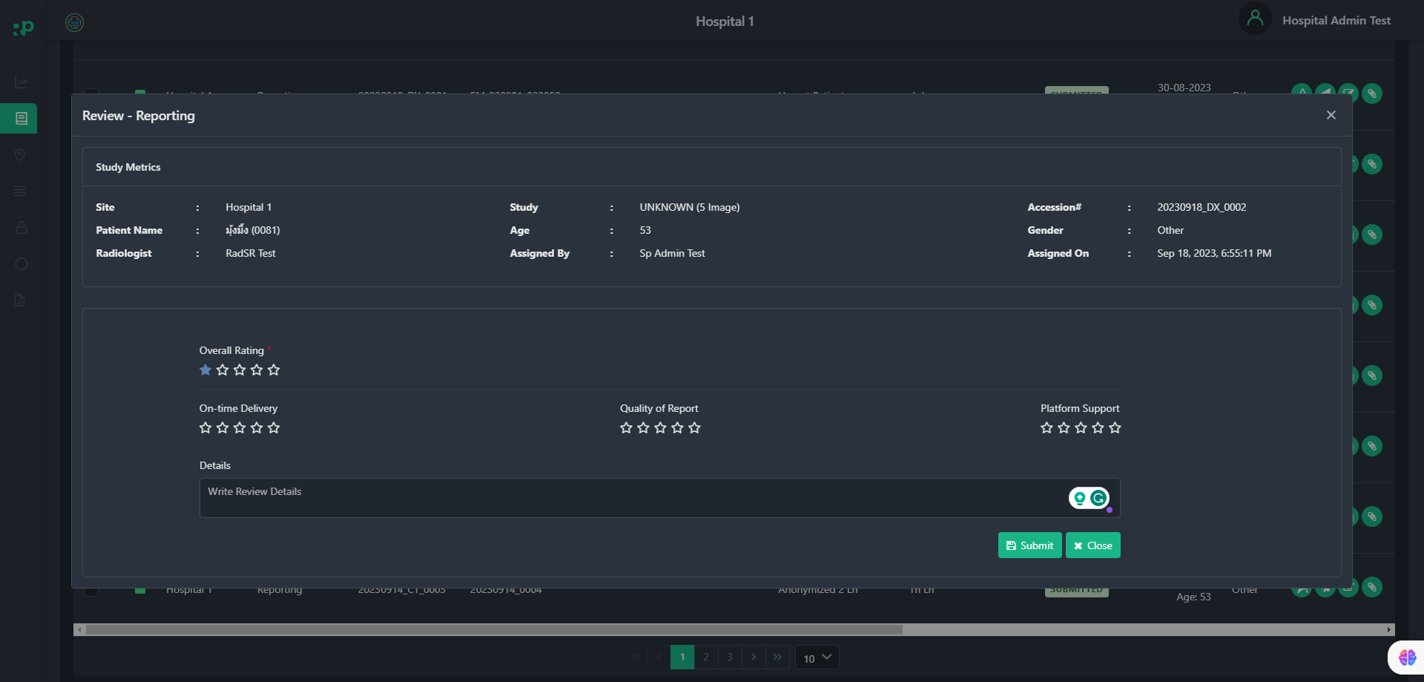

3. How to Track Studies
This option allows you to track all studies within the RadPortal system in a well-organized and structured way.
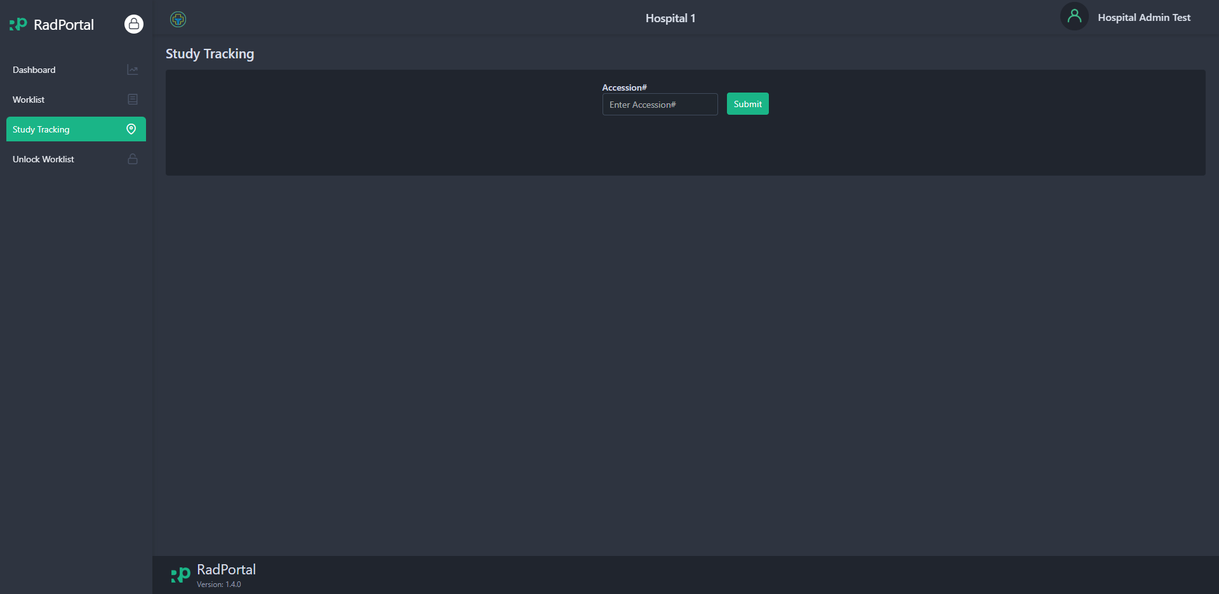

To track studies, you have to enter the accession number of a study. You can find the accession number from the Study Worklist option.
To review or track the study insert the study accession number in the Accession field and click on the Submit button. 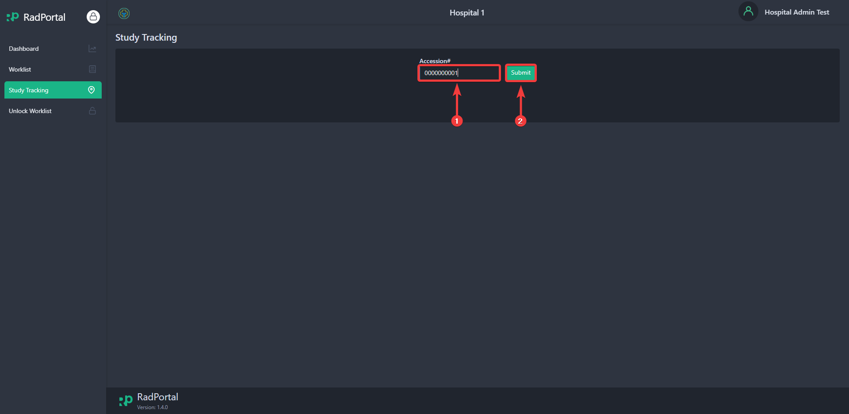

After clicking on submit, you should see information with the status history of the specific study.
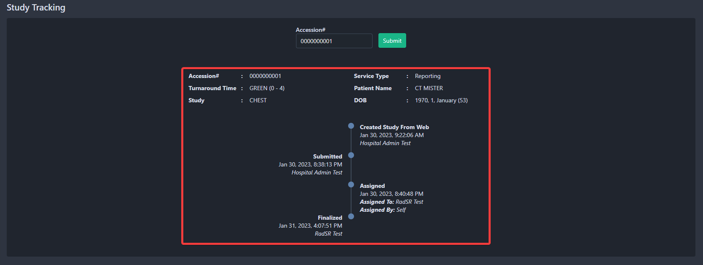

There are two sections in study tracking. 1. Study Information, 2. Study Status & History.
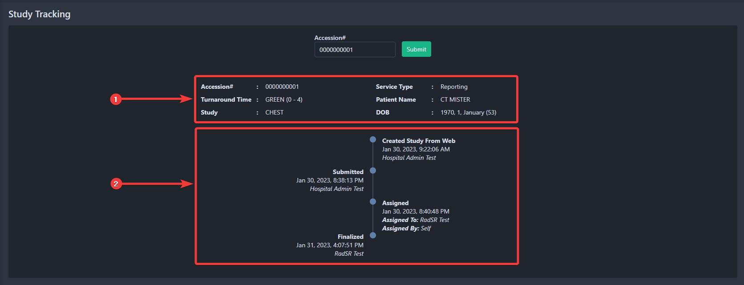

4. Integration Monitoring Center
This option allows you to monitor and review information for the Data Center and Local PACS, Radiology Information System, and Govt. Info submit status. You can Resend this information from this module as well.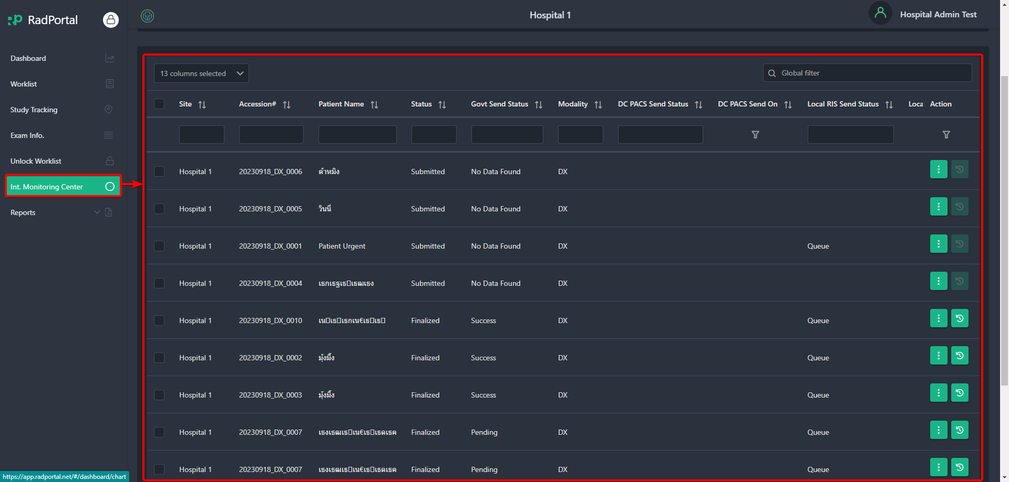

To resend information click on the Resend Type field and choose type and click on the Resend button.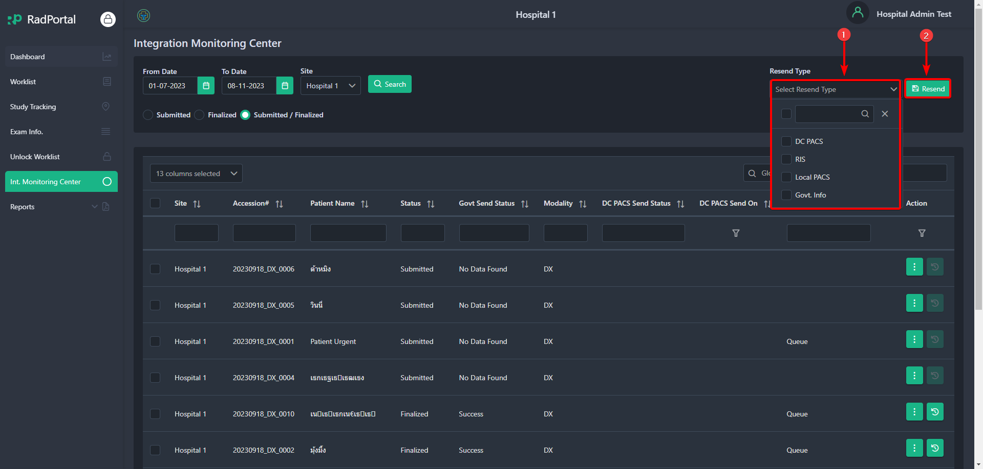

5. Reports
This option allows you to view finalized Reports, Radiologist Workload Summary, Govt. Info, Radiologist, Ranking Analysis, Case Reset Reports. To view reports, click on the report view option. 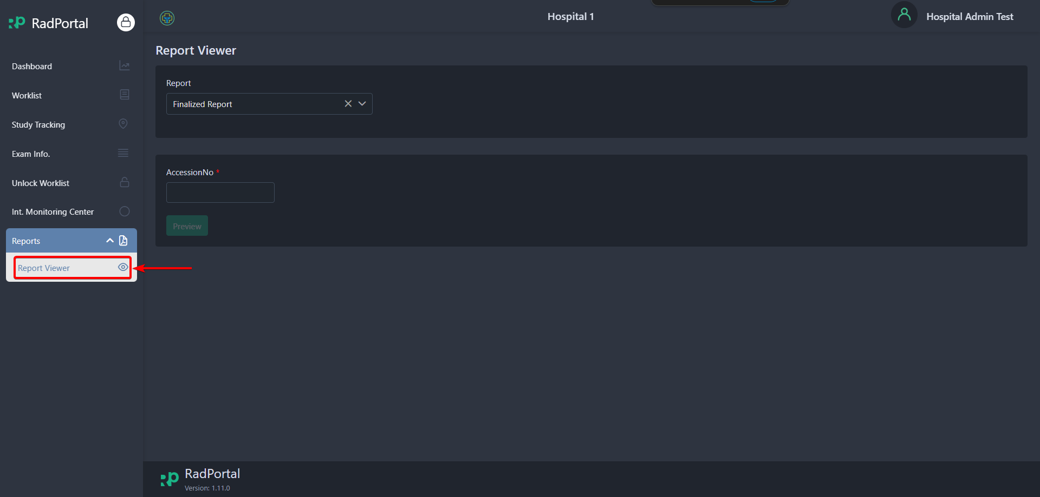

To view a report of a study using the report viewer click on the Report and select the type of report you want to review. 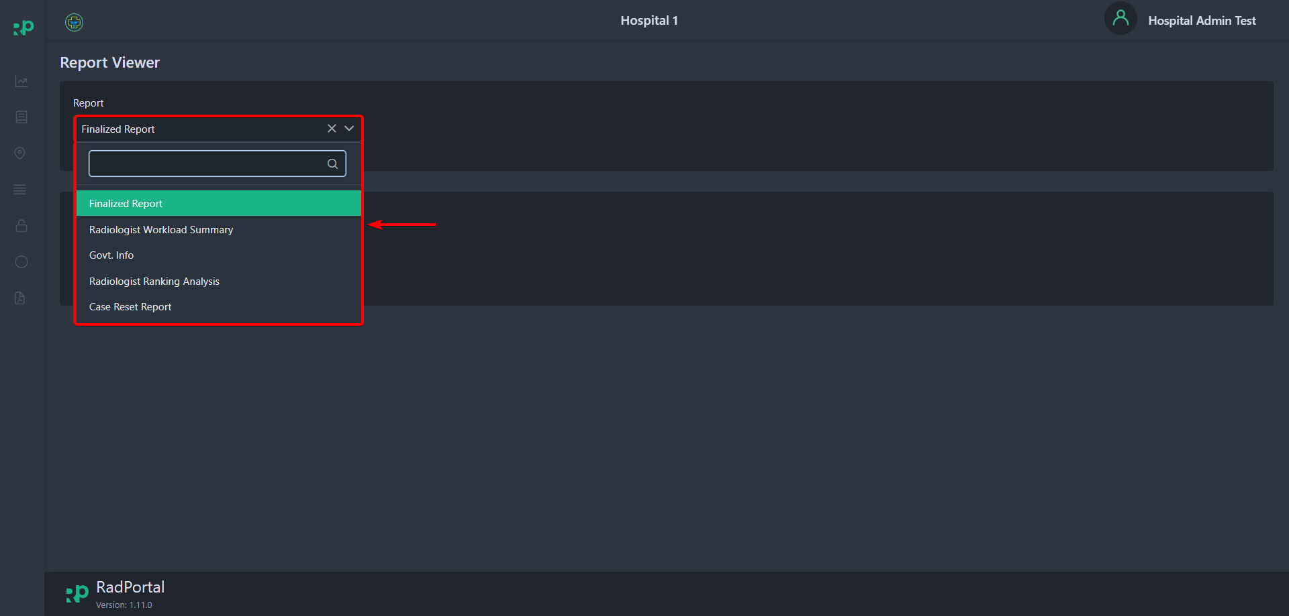

In this case, we are reviewing the Finalized Report. After selecting the Finalized Report you have to enter the Accession number of the study. As you start to enter the Accession Number you should see the Accession Number below along with the Hospital Name. Now Click on the Accession Number.
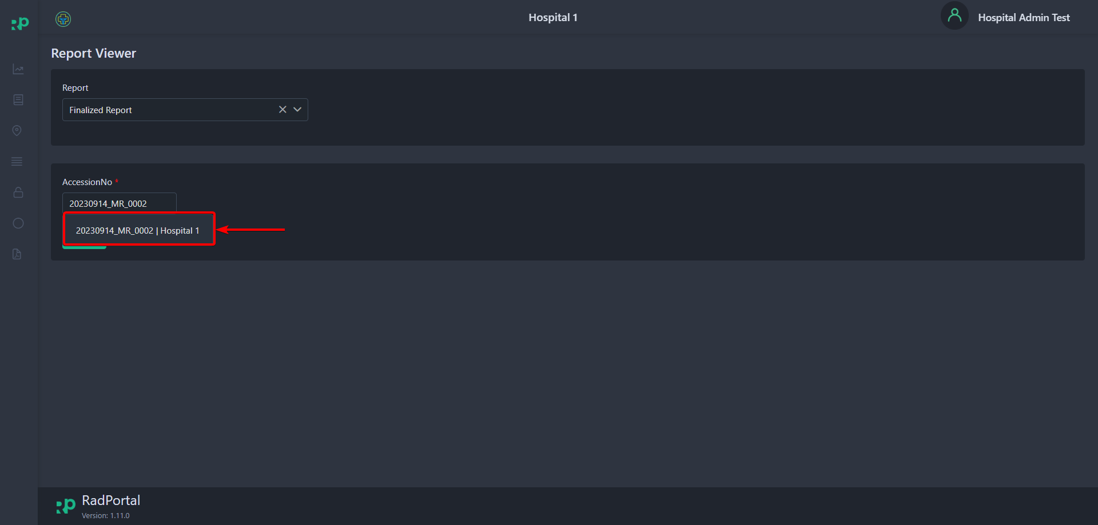

After selecting click on the Preview Button.
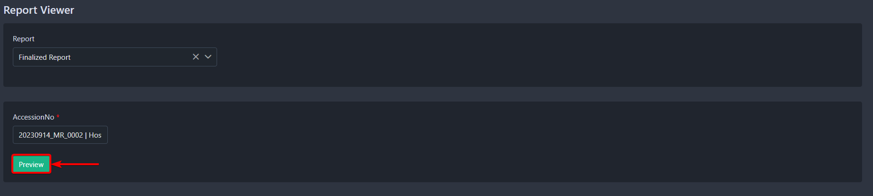

After clicking you should see the Finalized Report. You can download or print the finalized report by clicking on the Download[1] and Print[2] button.